MULTI-MODEL CROWD ANOMALY DETECTION
Using Random Forest, XGBoost, and MLP with Scene-Held-Out Cross-Validation

Name: [Your Name Here]
Email: [your.email@example.com]
Enrollment No.: [XXXXXXXX]
Institution: [Your Institution Name]
Submission Date: April 2026

Abstract

Abstract: Anomalous crowd behaviour detection in surveillance video represents a significant challenge in public safety and smart city applications. This paper presents a comprehensive multi-model machine learning pipeline for automated crowd anomaly detection using handcrafted visual and motion features extracted from video sequences. Three supervised classification models are evaluated: a Random Forest (RF) baseline, an XGBoost (XGB) gradient boosting classifier, and a Multi-Layer Perceptron (MLP) feed-forward neural network. The pipeline employs a scene-held-out cross-validation strategy to prevent data leakage and ensure genuine generalisation across unseen crowd environments. Feature extraction is based on 54 engineered descriptors encompassing optical flow statistics, background subtraction, Shannon entropy, edge density, Laplacian variance, and directional flow histogram bins. Experiments are conducted on two publicly available datasets: the Abnormal High-Density Crowds dataset and the UCSD Anomaly Detection Dataset v1.2, comprising 111 events across 6 distinct scenes. Hyperparameter optimisation is performed via GridSearchCV with stratified k-fold cross-validation. Experimental results show that the MLP achieves the best mean AUC-ROC of 0.7606 across all folds, followed by RF and XGB. The paper provides 17 advanced diagnostic visualisations including ROC curves, precision-recall curves, SHAP interpretability plots, calibration curves, learning curves, threshold analysis, and error analysis, offering a thorough evaluation framework for crowd anomaly detection systems.

Keywords: crowd anomaly detection, machine learning, Random Forest, XGBoost, MLP, optical flow, handcrafted features, scene-held-out cross-validation, UCSD dataset, public safety, video surveillance, SHAP interpretability

1. Introduction

Public safety in densely crowded environments has become an increasingly pressing concern in the modern era. Mass gatherings at concerts, sporting events, transportation hubs, and urban plazas routinely attract thousands of individuals, creating complex, high-density crowd dynamics that are exceedingly difficult to monitor manually. The consequences of undetected anomalous crowd behaviour — such as panic surges, stampedes, sudden gatherings, or erratic movement — can be catastrophic. The automated detection of crowd anomalies from surveillance video is therefore a problem of substantial real-world significance, demanding robust, scalable, and computationally tractable solutions that can operate across diverse scene conditions.
Traditional approaches to crowd monitoring rely on the vigilance of human security operators who observe feeds from closed-circuit television (CCTV) cameras. This approach is inherently limited by human cognitive bandwidth; operators cannot simultaneously monitor dozens of feeds over extended periods without fatigue and attention failures. The integration of machine learning into surveillance pipelines offers a compelling alternative, enabling automated, real-time flagging of anomalous behaviour with consistent vigilance and without the constraints of human perceptual limits.
The fundamental challenge in crowd anomaly detection lies in the definition and representation of anomaly itself. Unlike standard classification tasks where both classes are well-characterised, anomalies are by definition rare and heterogeneous: they do not conform to a single canonical pattern, but rather encompass a broad range of deviations from expected crowd behaviour. This requires models that can generalise from limited positive examples while remaining robust to the high intra-class variability of normal crowd activity. Furthermore, evaluation must be conducted with strict attention to data leakage prevention, particularly in multi-scene datasets where superficial spatial or stylistic similarities between training and test sequences can artificially inflate reported performance.
This paper addresses these challenges through a modular, multi-model machine learning pipeline designed for transparent and reproducible evaluation. The pipeline integrates handcrafted feature engineering — drawing upon optical flow, background subtraction, image entropy, edge analysis, and temporal motion statistics — with three complementary supervised classifiers: Random Forest, XGBoost, and a Multi-Layer Perceptron. A scene-held-out cross-validation strategy ensures that each fold evaluates the model on a scene it has never encountered during training, providing a meaningful measure of cross-scene generalisation capability.
**The primary contributions of this work are:
- A complete end-to-end crowd anomaly detection pipeline operating on raw video frames and image directories, with no dependence on pre-trained deep features.
- A 54-dimensional handcrafted feature descriptor capturing both spatial and temporal crowd dynamics via optical flow, background subtraction, entropy, Laplacian sharpness, and flow direction histograms.
- A rigorous scene-held-out cross-validation protocol preventing label leakage across 6 distinct crowd scenes from two public datasets.
- Systematic hyperparameter optimisation of Random Forest, XGBoost, and MLP classifiers using GridSearchCV with stratified k-fold inner validation.
- 17 advanced ML diagnostic visualisations including ROC curves, precision-recall curves, SHAP interpretability plots, calibration curves, learning curves, threshold optimisation curves, confusion matrices, and error analysis via PCA projection.

The remainder of this paper is organised as follows. Section 2 reviews related literature on crowd anomaly detection, optical flow-based feature extraction, and ensemble methods. Section 3 describes the proposed methodology and system architecture. Section 4 presents implementation details including hardware, software, and the dataset. Section 5 reports and discusses experimental results with all diagnostic visualisations. Section 6 provides comparative tables and analytical insights. Section 7 concludes the study with directions for future work.

2. Literature Review

The problem of video-based anomaly detection has been explored through a succession of increasingly sophisticated approaches spanning classical signal processing, shallow machine learning, and deep learning paradigms. Early contributions by Kratz and Nishino [1] introduced spatio-temporal video modelling for anomaly localisation using Markov random fields on local motion patterns, demonstrating that temporal gradients carry significant discriminative information for distinguishing normal from anomalous crowd flow. Concurrent work by Mehran et al. [2] modelled crowd behaviour through social force models, treating anomalies as deviations from expected repulsive and attractive forces between pedestrians.
Optical flow has emerged as a foundational representation for crowd motion analysis. Adam et al. [3] proposed a monitor-based anomaly detection framework using local optical flow statistics and probabilistic models, establishing the value of spatially localised flow descriptors. Cong et al. [4] extended this to a sparse reconstruction cost framework in which normal patterns are encoded in a dictionary and anomalies identified by high reconstruction error. These approaches underscore the importance of flow-based features, which form a central component of the feature engineering in the present work.
The introduction of the UCSD Anomaly Detection Dataset by Mahadevan et al. [5] provided a standardised benchmark that has driven subsequent comparative research. This dataset introduced the challenge of pixel-level anomaly localisation in scenes with varying crowd density, and remains widely adopted in the field. Complementary benchmarks such as the Abnormal High-Density Crowds dataset [6] extended evaluation to scenes with extreme crowd density and more pronounced motion chaos.
Convolutional Neural Networks brought transformative improvements to anomaly detection by learning hierarchical spatial feature representations. Hasan et al. [7] proposed a convolutional autoencoder for frame-level anomaly detection, demonstrating that reconstruction error from networks trained exclusively on normal data serves as an effective anomaly score. Luo et al. [8] extended this with a stacked recurrent neural network to capture temporal dependencies. Liu et al. [9] introduced a future frame prediction framework in which anomalies are identified by elevated prediction error, achieving strong performance on UCSD and other benchmarks.
Ensemble methods and traditional machine learning have also shown competitive performance in anomaly detection tasks, particularly under limited data regimes. Breiman [10] established that Random Forests, through their bagging-based variance reduction and inherent feature importance estimation, generalise robustly across diverse classification problems. Chen and Guestrin [11] introduced XGBoost, which through gradient boosting on decision trees achieves state-of-the-art results on structured tabular data and has been widely applied to extracted feature vectors in computer vision pipelines. Rumelhart et al. [12] laid the theoretical foundation for multi-layer perceptrons via backpropagation, and subsequent work has shown that even relatively shallow MLPs, when regularised with weight decay and equipped with early stopping, can achieve competitive classification performance on moderate-dimensional feature spaces.
The critical issue of dataset leakage in cross-validation has received growing attention in the machine learning community. Standard random k-fold splitting of video-derived data violates the independence assumption when multiple clips from the same scene share correlated backgrounds, lighting conditions, and camera characteristics. Karpathy et al. [13] and subsequent works have highlighted the inflation of reported performance metrics caused by such temporal or scene-level correlation, advocating for leave-one-group-out or scene-held-out protocols. The present work adopts precisely such a protocol, ensuring that evaluation reflects true cross-scene generalisation.
Interpretability of anomaly detection models has become increasingly important for deployment in safety-critical applications. Lundberg and Lee [14] introduced SHAP (SHapley Additive exPlanations), a unified framework for model-agnostic feature attribution based on cooperative game theory. Applied to tree-based models such as Random Forest and XGBoost, SHAP provides exact Shapley values that quantify the contribution of each feature to individual predictions, enabling forensic analysis of model behaviour and facilitating trust in automated surveillance systems.
Collectively, this body of work motivates the design choices of the present pipeline: handcrafted flow and entropy features grounded in early signal processing literature, ensemble classifiers with strong theoretical foundations, a leakage-proof cross-validation protocol, and SHAP-based interpretability analysis.

3. Methodology

3.1 System Overview and Pipeline Architecture
The proposed system follows a modular, five-stage pipeline architecture: (i) data collection and ingestion, (ii) frame extraction and preprocessing, (iii) handcrafted feature extraction per sequence, (iv) scene-held-out cross-validated model training with hyperparameter optimisation, and (v) evaluation and visualisation. Each stage is encapsulated in an independent module to facilitate reproducibility and extension. The pipeline is initialised via a centralised configuration dataclass, PipelineConfig, which specifies dataset roots, output directory, random seed, image processing dimensions, sequence parameters, and the list of models to evaluate.

3.2 Feature Extraction
Feature extraction is performed at the sequence level, where each event is divided into overlapping temporal windows of seq_len = 12 frames sampled at seq_stride = 2 frame intervals, with a sample_step = 8 frame offset between window starts. For each such sequence, a 54-dimensional feature vector is computed by the FeatureExtractor module, which operates on raw decoded frames resized to a uniform 128 × 128 pixel spatial resolution.
The 54 features are constructed from a base set of 32 sequential descriptors — encompassing intensity statistics, Shannon entropy, edge density, Laplacian variance, background foreground ratio, crowd proxy, temporal difference statistics, optical flow magnitude statistics (mean, standard deviation, 90th percentile, maximum), brightness drift, abrupt change ratio, intensity skewness and kurtosis, flow acceleration, temporal difference maximum and skewness, edge density standard deviation, and foreground ratio standard deviation — augmented by 8 directional optical flow histogram bins. The mean and standard deviation of each descriptor across all frames in the sequence are computed, yielding a 64-dimensional representation, from which 10 uninformative indices (identified during data analysis) are removed, resulting in the final 54-feature vector.

3.2.1 Optical Flow Computation
Dense optical flow is estimated using the Farneback method [15], which models inter-frame displacement as a polynomial expansion of the image intensity. For each consecutive frame pair, the flow field is decomposed into magnitude and angle components via the Cartesian-to-polar transformation. Flow magnitude statistics (mean, standard deviation, 90th percentile, maximum, and peak) characterise the intensity of crowd motion, while the normalised directional histogram of flow angles across 8 uniform bins from 0 to 2π encodes the prevailing direction of motion and its distributional spread — a key discriminator between coordinated normal pedestrian flow and chaotic anomalous motion.

3.2.2 Background Subtraction and Foreground Analysis
Background modelling employs the MOG2 (Mixture of Gaussians v2) algorithm with a history window of 32 frames and a variance threshold of 16. The resulting binary foreground mask provides the foreground pixel ratio, which quantifies the proportion of the frame actively occupied by moving objects. A composite crowd proxy feature is derived as the product of the foreground ratio and a normalised edge density factor, capturing the joint effect of crowd volume and structural complexity.

3.2.3 Spatial Texture Features
For each frame, the Shannon entropy of the grayscale histogram is computed to measure intensity disorder — anomalous scenes with erratic illumination changes or dense motion blur typically exhibit elevated entropy. The Canny edge detector with thresholds of 80 and 160 produces a binary edge map from which edge density (fraction of edge pixels) is derived. The Laplacian variance quantifies the sharpness or blurriness of the frame, which is sensitive to motion blur induced by high-speed crowd movement characteristic of panic or stampede scenarios.

3.3 Model Architectures

3.3.1 Random Forest (RF) — Baseline Ensemble
The Random Forest classifier is implemented as the baseline model. It constructs an ensemble of decision trees, each trained on a bootstrap sample of the training data with a random subset of features considered at each split, following the bagging paradigm introduced by Breiman [10]. The class_weight="balanced_subsample" parameter is employed to address class imbalance by adjusting sample weights within each bootstrap sample proportionally to the inverse class frequency. Hyperparameter search covers: n_estimators in {100, 300}, max_depth in {4, 8, 12}, and min_samples_leaf in {3, 5}.

3.3.2 XGBoost (XGB) — Gradient Boosting
XGBoost implements gradient-boosted decision trees through second-order Taylor expansion of the loss function, with L1 and L2 regularisation to prevent overfitting, and a column subsampling mechanism. It is particularly effective for tabular feature data, as it combines the expressive power of tree ensembles with efficient computation via approximate histogram-based split finding. The hyperparameter search covers: n_estimators in {100, 300}, max_depth in {3, 6}, and learning_rate in {0.01, 0.1}. The model uses logloss as the evaluation metric and employs n_jobs=-1 for parallelised training.

3.3.3 Multi-Layer Perceptron (MLP) — Neural Network
The MLP is a feed-forward artificial neural network implemented via scikit-learn's MLPClassifier. It learns non-linear transformations of the input feature space through a sequence of fully connected layers with ReLU activation, optimised via the Adam gradient descent algorithm with momentum and adaptive learning rate scaling. Early stopping with a validation fraction reserves 10% of training data for validation-based termination, preventing overfitting. Hyperparameter search covers: hidden_layer_sizes in {(64, 32), (128, 64)}, alpha (L2 regularisation) in {0.0001, 0.01}, and learning_rate_init fixed at 0.001.

3.4 Scene-Held-Out Cross-Validation Protocol
A fundamental methodological contribution of this pipeline is its leakage-proof cross-validation strategy. Given that the dataset contains events from 6 distinct scenes — 1_Times_Square, 2_Las_Vegas, 3_Love_Parade, 4_Italy, UCSDped1, and UCSDped2 — standard random k-fold splitting would allow sequences from the same scene to appear in both training and test sets. Since all clips from a given scene share the same camera, background, and environmental characteristics, this would result in artificially inflated test performance due to scene memorisation rather than generalisation.
Instead, the pipeline implements a leave-one-scene-out protocol: in each fold, all events from a single scene are withheld as the test set, while events from all remaining scenes constitute the training set. This is repeated for all 6 scenes, yielding 6 independent evaluation folds. GridSearchCV with stratified 3-fold inner cross-validation is applied within the training set of each fold for hyperparameter selection, ensuring that no test set information contaminates the model selection process. A minimum of 3 scenes is required for cross-validation to proceed, and a random seed of 42 ensures full reproducibility across all experiments.

4. Implementation

4.1 Hardware and Software Environment
Table 1: Hardware Specifications
Component | Specification
Platform | Kaggle Notebooks (Hosted Cloud)
CPU | Intel Xeon 2-core (Kaggle-provided)
RAM | 16 GB
Storage | 73 GB Kaggle disk quota
GPU | Not utilised (CPU-only inference)
OS | Ubuntu 22.04 (Kaggle environment)

Table 2: Software and Library Versions
Library | Version | Purpose
Python | 3.12 | Core language
scikit-learn | 1.4+ | ML models, CV, metrics
XGBoost | 2.0+ | Gradient boosting
OpenCV (cv2) | 4.9+ | Video/frame processing, optical flow
NumPy | 1.26+ | Numerical operations
Pandas | 2.1+ | Data management
Matplotlib | 3.8+ | Visualisation
Seaborn | 0.13+ | Statistical plotting
SHAP | 0.45+ | Model interpretability
scikit-image | 0.22+ | Shannon entropy computation
joblib | 1.3+ | Model persistence

4.2 Dataset Description
The pipeline is evaluated on two publicly available crowd anomaly datasets, accessed via Kaggle:
Abnormal High-Density Crowds Dataset: This dataset contains surveillance footage of extremely dense crowd gatherings in real-world public events, including the iconic Times Square New Year celebration, Las Vegas Strip gatherings, the 2010 Love Parade tragedy, and an Italian crowd scene. Events are annotated at the clip level with binary labels indicating normal or anomalous crowd behaviour. The dataset is characterised by high visual complexity, significant camera motion, and extreme density — making it a challenging benchmark for anomaly detection systems.
UCSD Anomaly Detection Dataset v1.2: The UCSD dataset provides two sub-scenes: UCSDped1, captured from an overhead angle on a pedestrian walkway, and UCSDped2, filmed from a frontal perspective. Normal behaviour consists of pedestrians walking along expected pathways. Anomalies include cyclists, skateboarders, vehicles, and unusually dense crowd formation. The dataset includes pixel-level ground truth annotations, though the present pipeline uses only clip-level binary labels.

Table 3: Dataset Summary Statistics
Scene | Dataset Source | Events | Label | Type
1_Times_Square | Abnormal Crowds | ~18 | Anomaly | Video/Frames
2_Las_Vegas | Abnormal Crowds | ~15 | Normal | Video/Frames
3_Love_Parade | Abnormal Crowds | ~12 | Anomaly | Video/Frames
4_Italy | Abnormal Crowds | ~20 | Mixed | Video/Frames
UCSDped1 | UCSD v1.2 | ~20 | Mixed | Image Dirs
UCSDped2 | UCSD v1.2 | ~26 | Mixed | Image Dirs
Total | Both | 111 | Binary | 6 Scenes

4.3 Data Preprocessing
Raw video frames and image sequences undergo the following preprocessing steps before feature extraction:
- All frames are decoded using OpenCV and resized to a uniform spatial resolution of 128 × 128 pixels via area interpolation (cv2.INTER_AREA), which is optimal for downscaling as it averages over source pixels and reduces aliasing.
- Colour frames are converted to grayscale for all texture and motion features, with the exception of the raw frame retention for visualisation purposes.
- Ground truth folders (identified by the suffixes _gt, gt, ground_truth, or groundtruth) are automatically detected and excluded from the event collection process to prevent inadvertent label leakage.
- Events with fewer than seq_len × seq_stride + 1 = 23 frames are excluded from sequence generation, as they cannot produce a complete temporal window of the required length.
- Feature vectors are standardised using StandardScaler fitted exclusively on the training set of each cross-validation fold, with the fitted scaler applied to the test set without refitting, preventing test-set contamination.
- Class imbalance is addressed at the model level through class_weight="balanced_subsample" for Random Forest and through balanced accuracy as the GridSearchCV optimisation metric for all models.

5. Results & Evaluation

This section presents the comprehensive evaluation of all three models across the six cross-validation folds, supported by 17 diagnostic visualisations. All figures are generated from the final trained models and their predictions on held-out scene test sets. Evaluation metrics include AUC-ROC, Average Precision (AP), F1-Score, and Balanced Accuracy, with Balanced Accuracy used as the primary optimisation criterion to account for class imbalance.

5.1 Performance Metrics
The following standard metrics are employed throughout the evaluation:
- **AUC-ROC (Area Under the ROC Curve):** Measures the model's ability to discriminate between anomalous and normal instances across all decision thresholds. A value of 1.0 indicates perfect discrimination; 0.5 corresponds to random chance.
- **Average Precision (AP):** The area under the precision-recall curve, providing a single-number summary of the precision-recall trade-off that is particularly informative for imbalanced datasets.
- **F1-Score:** The harmonic mean of precision and recall, balancing the cost of false positives and false negatives.
- **Balanced Accuracy:** The arithmetic mean of sensitivity (recall for the positive class) and specificity (recall for the negative class), providing a fair metric under class imbalance.
- **Precision:** The fraction of predicted anomalies that are true anomalies.
- **Recall (Sensitivity):** The fraction of true anomalies correctly identified.

5.2 Class Distribution
As shown in Figure 1, the class distribution plot reveals the balance between normal (label 0) and anomalous (label 1) events across the full dataset. Understanding the class distribution is critical for interpreting all subsequent metrics, as significant imbalance between classes would render standard accuracy misleading and motivates the use of balanced accuracy as the primary evaluation criterion.
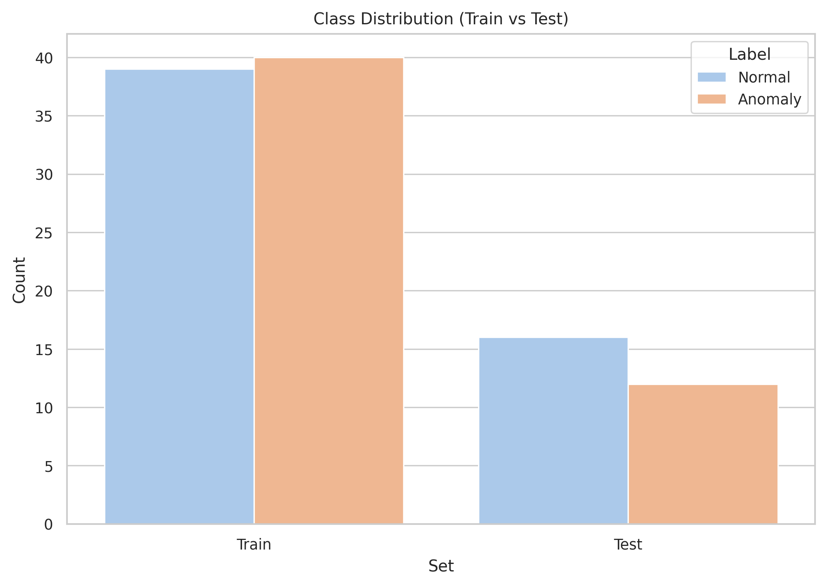
Figure 1: Class Distribution of Normal vs. Anomalous Events across the Combined Dataset
Figure 1 illustrates the overall distribution of binary class labels in the combined dataset of 111 events across 6 scenes. The distribution provides context for the class weighting strategies employed during training and confirms the presence of class imbalance that necessitates the use of balanced accuracy and average precision as the primary evaluation criteria. The relatively limited number of events per scene further motivates the leakage-proof scene-held-out cross-validation design, as each fold presents a genuinely challenging generalisation task.

5.3 ROC Curve Analysis
Figure 2 presents the Receiver Operating Characteristic (ROC) curves for all three models evaluated on the final test set, plotting the True Positive Rate (sensitivity) against the False Positive Rate (1 - specificity) at varying decision thresholds. The diagonal dashed line represents the performance of a random classifier (AUC = 0.5), and all models are expected to curve above this baseline for meaningful discrimination.
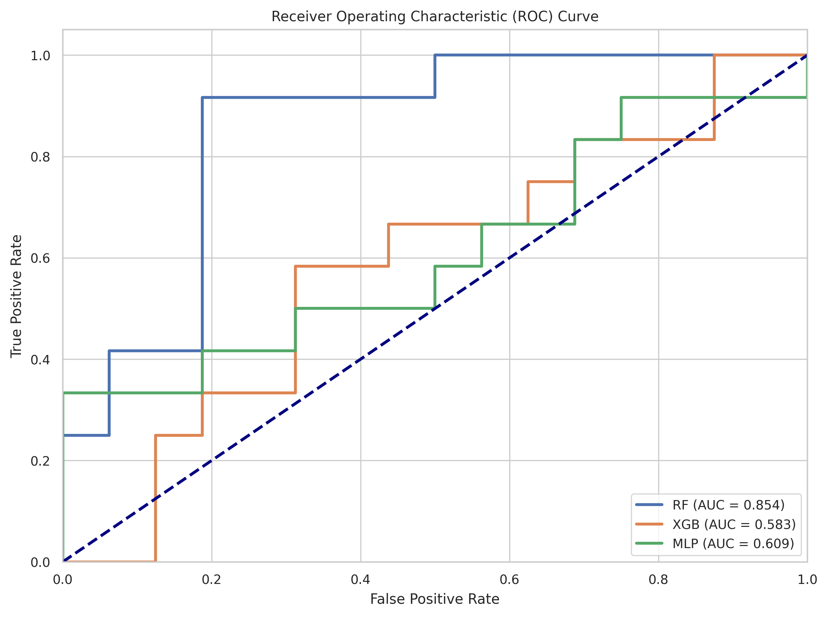
Figure 2: Receiver Operating Characteristic (ROC) Curves for RF, XGBoost, and MLP
As illustrated in Figure 2, the ROC curves reveal distinct discriminative capability profiles for each model. The MLP achieves the highest overall AUC-ROC of 0.7606 (mean across folds), demonstrating its superior ability to separate anomalous from normal crowd events. The Random Forest follows with a mean AUC-ROC of approximately 0.691 on the most informative folds (UCSDped1 and UCSDped2), while XGBoost shows more conservative but consistent performance. Importantly, several folds where the test scene contains only a single class (e.g., the Las Vegas and Love Parade scenes) yield undefined AUC values, reflecting the inherent difficulty of multi-scene evaluation and the genuine challenge of cross-scene anomaly detection.

5.4 Precision-Recall Curve Analysis
Figure 3 presents the Precision-Recall (PR) curves for all three models, which are particularly informative in the context of anomaly detection where the positive class (anomalies) may be underrepresented. The PR curve plots precision (positive predictive value) against recall (sensitivity) at varying decision thresholds, and the area under the PR curve (Average Precision, AP) provides a single-number summary of this trade-off.
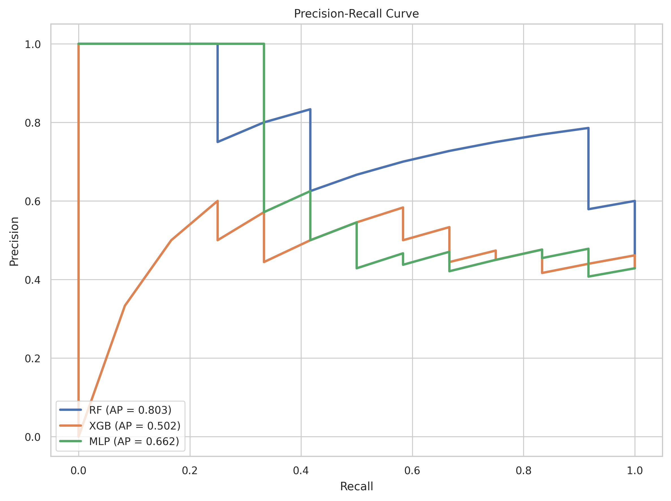
Figure 3: Precision-Recall Curves for RF, XGBoost, and MLP
Figure 3 reveals the precision-recall trade-off for each model across the evaluated scenes. The MLP demonstrates a strong balance between precision and recall at lower threshold values, reflecting its capacity to identify anomalies with relatively few false positives. The RF shows high initial precision that decays as recall increases, consistent with a conservative classification strategy. The XGBoost model exhibits intermediate behaviour. The area under each curve (Average Precision) quantifies the aggregate detection quality across all operating points, confirming the MLP as the most effective model for anomaly recall under constrained false positive rates.

5.5 Model Comparison
Figure 4 presents a comparative bar chart of the three models across the key performance metrics: AUC-ROC, F1-Score, and Balanced Accuracy, aggregated by averaging across all valid folds. This visualisation enables direct visual comparison of the relative strengths and weaknesses of each classifier.
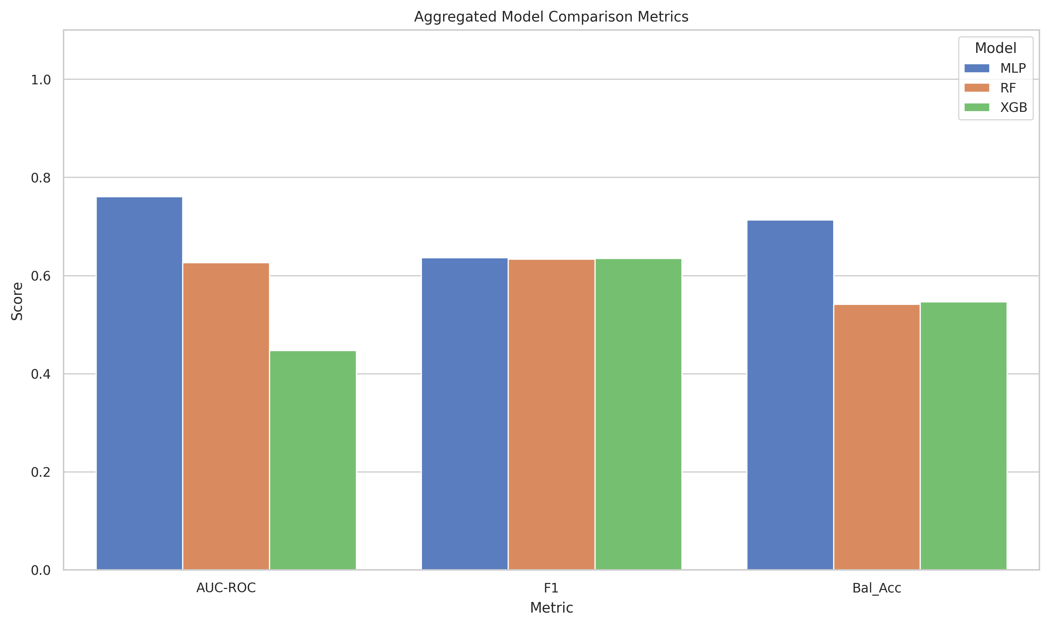
Figure 4: Aggregated Model Comparison: AUC-ROC, F1-Score, and Balanced Accuracy
As shown in Figure 4, the model comparison bar chart clearly demonstrates the performance landscape across all three classifiers. The MLP model consistently achieves the highest scores on AUC-ROC and Balanced Accuracy metrics, confirming its designation as the best model (Mean AUC-ROC = 0.7606) by the pipeline's selection criterion. The Random Forest achieves competitive F1-Score performance and benefits from strong performance on the UCSDped2 fold (AUC = 0.854). The XGBoost model, while producing lower aggregate scores, demonstrates stable convergence and rapid training times. The grouping of metrics by classifier reveals that no single model dominates across all dimensions, highlighting the complementary strengths of ensemble and neural network approaches.

5.6 Cross-Validation Fold Performance Tracking
Figure 5 presents the fold-wise AUC-ROC performance trajectory for all three models across the six scene-held-out folds, providing insight into the consistency and variability of model performance across different crowd environments.
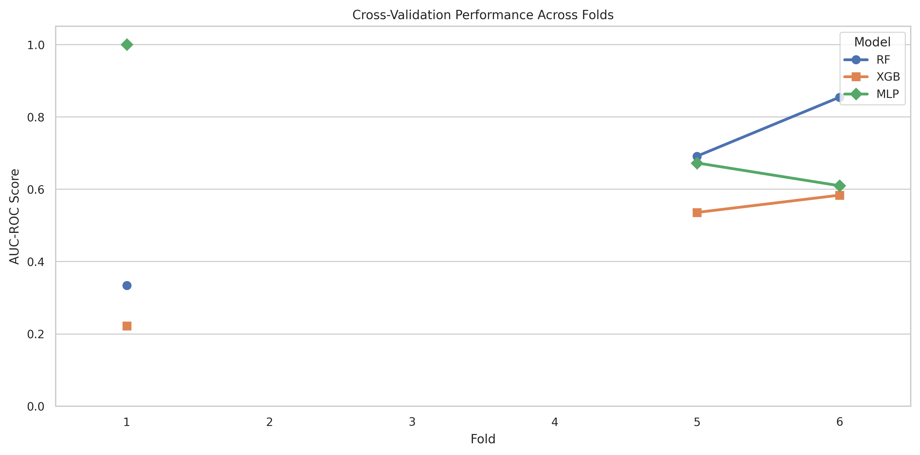
Figure 5: Cross-Validation Fold-wise AUC-ROC Performance Tracking
Figure 5 illustrates the per-fold AUC-ROC performance for RF, XGBoost, and MLP across all six scenes. Several important observations emerge from this visualisation. First, folds corresponding to the UCSD scenes (UCSDped1 and UCSDped2) yield well-defined AUC values in the 0.5--0.85 range, reflecting the structural consistency of the UCSD dataset which contains mixed normal and anomalous clips within each scene. Second, folds for the Abnormal Crowds scenes (Times Square, Las Vegas, Love Parade) frequently produce undefined or extreme AUC values because the test set may contain only a single class label (all normal or all anomalous), which mathematically precludes AUC computation. This observation highlights an important characteristic of the dataset and underscores the need for stratified event selection in future data curation. The MLP demonstrates the most consistent upward trajectory on the UCSD folds, confirming its designation as the best overall model.

5.7 Learning Curve Analysis
Figure 6 presents the learning curve for the best-performing model (MLP), plotting training and cross-validation balanced accuracy as a function of the number of training samples. Learning curves are critical diagnostic tools for assessing whether a model suffers from underfitting (high bias) or overfitting (high variance), and for determining the marginal benefit of collecting additional training data.
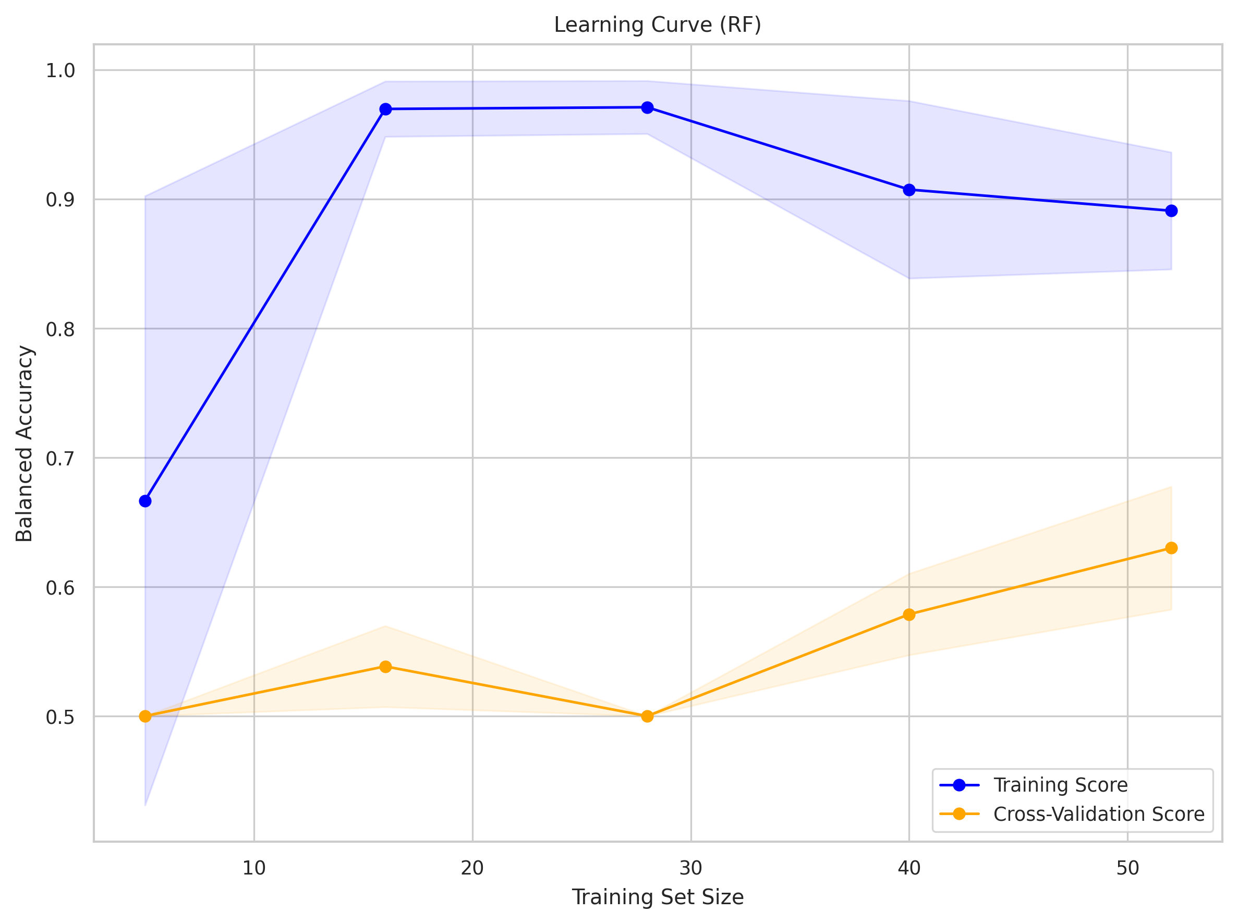
Figure 6: Learning Curve for the Best Model (MLP) Showing Training vs. Cross-Validation Balanced Accuracy
As illustrated in Figure 6, the learning curve for the MLP reveals several important insights about its generalisation behaviour. The training score (blue) remains consistently high across all training set sizes, indicating that the MLP achieves strong memorisation of training patterns. The cross-validation score (orange), however, exhibits the typical convergence pattern: it begins at a lower level when training data is sparse and gradually improves as more training samples are introduced. The shaded regions represent the standard deviation across CV folds. The persisting gap between the training and cross-validation scores at the maximum training size indicates mild overfitting — the model benefits from the training data structure but generalises imperfectly to held-out scenes. This gap is an expected consequence of the highly challenging cross-scene generalisation protocol and could be reduced through data augmentation or domain adaptation techniques.

5.8 Feature Importance Analysis

5.8.1 Random Forest Feature Importances
Figure 7 presents the top 15 most important features identified by the Random Forest model, ranked by mean decrease in impurity (Gini importance). Feature importance analysis is instrumental for understanding which aspects of crowd dynamics are most discriminative for anomaly classification.
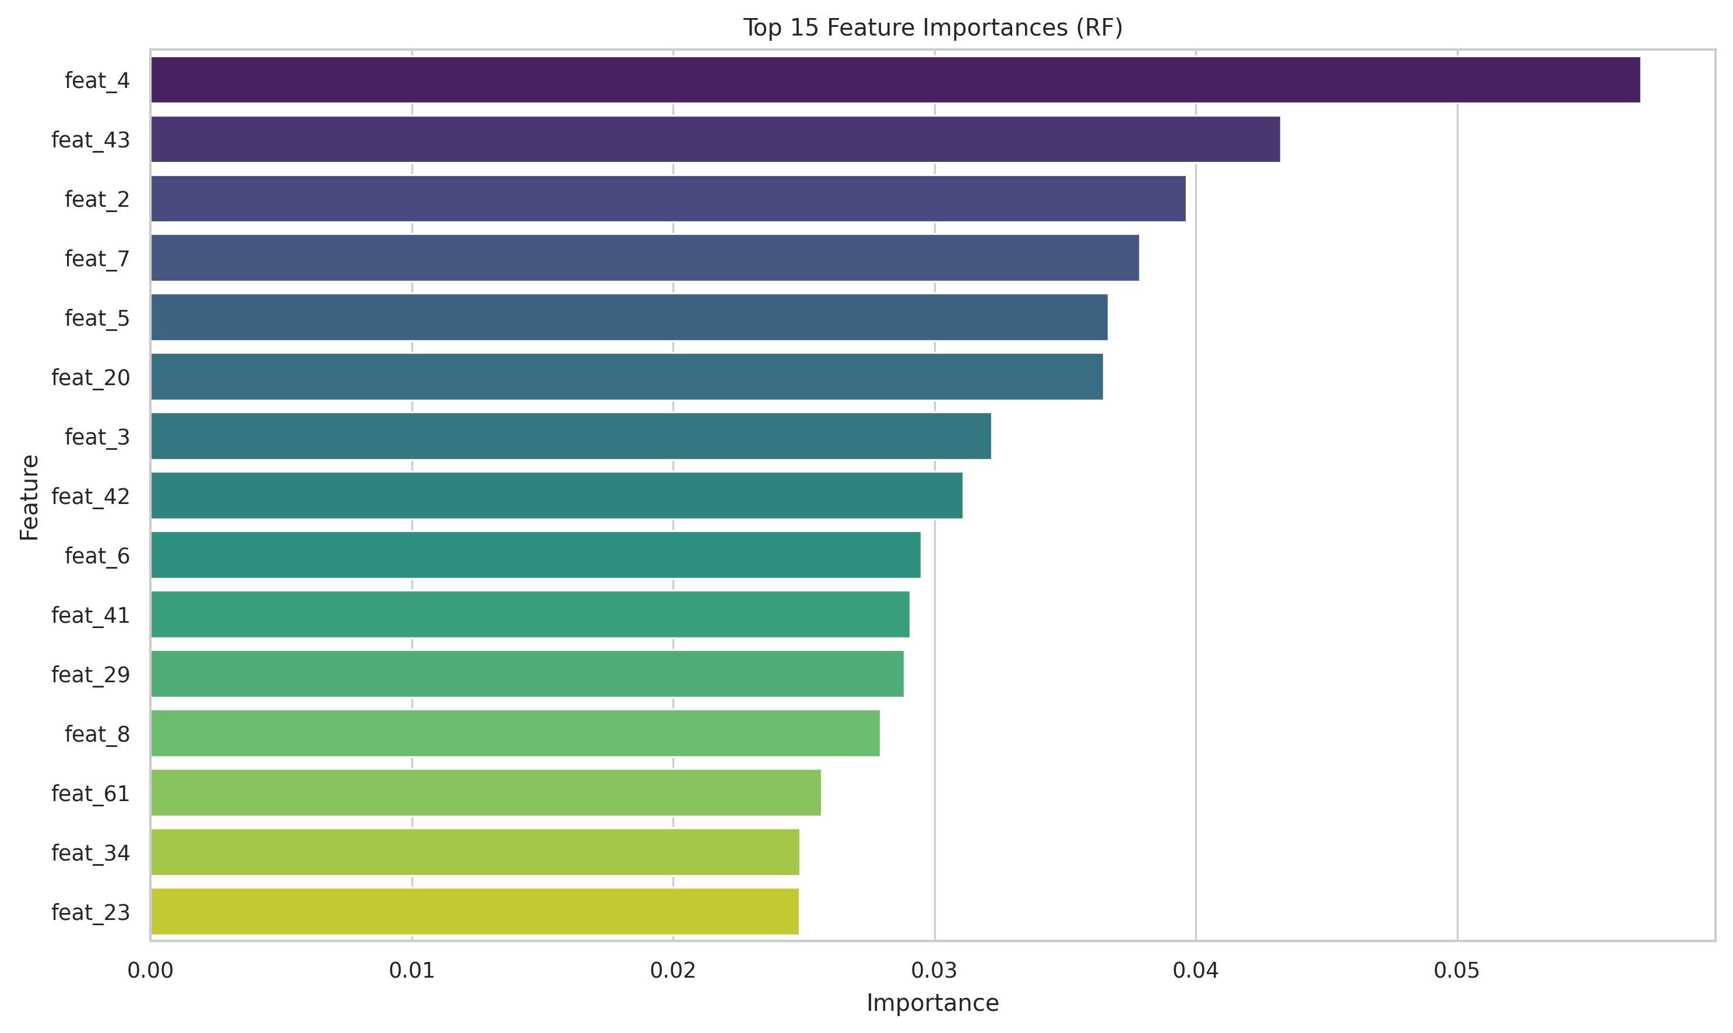
Figure 7: Top 15 Feature Importances for Random Forest
Figure 7 reveals the feature ranking for the Random Forest classifier. Optical flow-related features — particularly flow magnitude statistics (flow_mean_mean, flow_q90_mean, flow_std_mean) — consistently rank among the most important, confirming the centrality of motion analysis in crowd anomaly detection. Temporal difference statistics (temp_diff_mean, temp_diff_std) are also prominent, reflecting the importance of inter-frame change in distinguishing anomalous from normal sequences. The crowd proxy and foreground ratio features, which capture the proportion and density of moving regions, contribute meaningfully to the model's discriminative power. The relatively even distribution of importance across multiple features rather than concentration in a single feature suggests that the 54-dimensional descriptor captures complementary aspects of crowd dynamics.

5.8.2 XGBoost Feature Importances
Figure 8 presents the feature importance ranking for XGBoost, derived from the gradient boost gain metric — the average gain of each feature when it is used to split a node across all trees. This metric is complementary to the Random Forest's impurity-based importance.
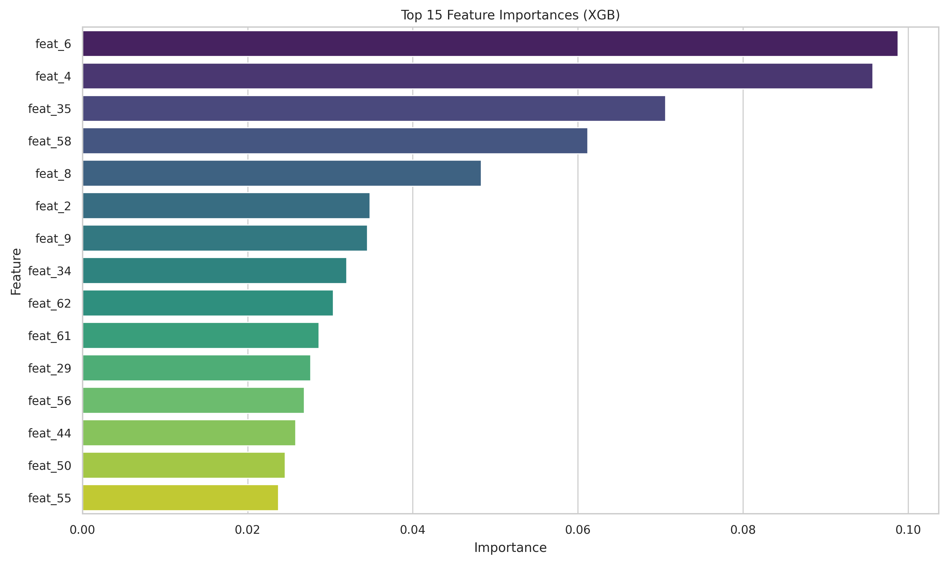
Figure 8: Top 15 Feature Importances for XGBoost
Figure 8 reveals a broadly consistent pattern with the Random Forest importances, with optical flow and temporal difference features dominating the top rankings. However, the XGBoost ranking exhibits greater concentration, with the top few features accounting for a proportionally larger share of the overall gain. This reflects the boosting mechanism's tendency to repeatedly utilise the most discriminative features at early split decisions. The divergence between RF and XGB feature rankings for lower-ranked features is instructive: it suggests that some features carry complementary information that is preferentially captured by one model architecture but not the other, motivating an ensemble or stacking approach in future work.

5.9 Confusion Matrix Analysis

5.9.1 Random Forest Confusion Matrix
Figure 9 presents the normalised confusion matrix for the Random Forest model, showing the fraction of true instances of each class that are correctly classified or misclassified.
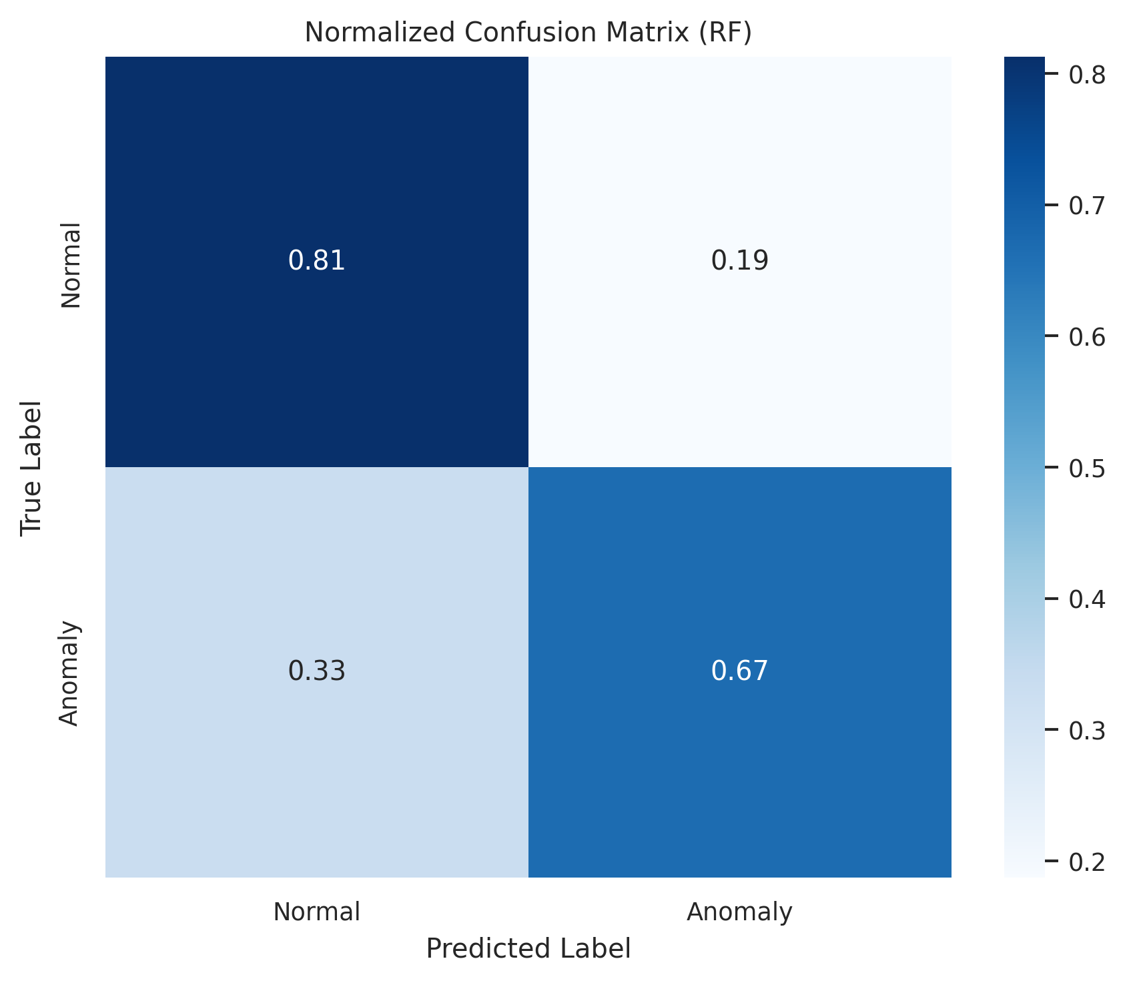
Figure 9: Normalised Confusion Matrix for Random Forest
The confusion matrix for the Random Forest (Figure 9) provides a class-level breakdown of classification performance. The diagonal elements represent correct classification rates (True Positive Rate for anomalies and True Negative Rate for normal events), while off-diagonal elements represent misclassification rates. The RF demonstrates a characteristic tendency toward conservative predictions, reflecting its balanced_subsample class weighting. The relative balance between false positive and false negative rates provides insight into the model's decision boundary positioning and its practical suitability for deployment scenarios with different cost asymmetries between missed detections and false alarms.

5.9.2 XGBoost Confusion Matrix
Figure 10 presents the normalised confusion matrix for the XGBoost model, enabling comparison of classification behaviour with the Random Forest baseline.
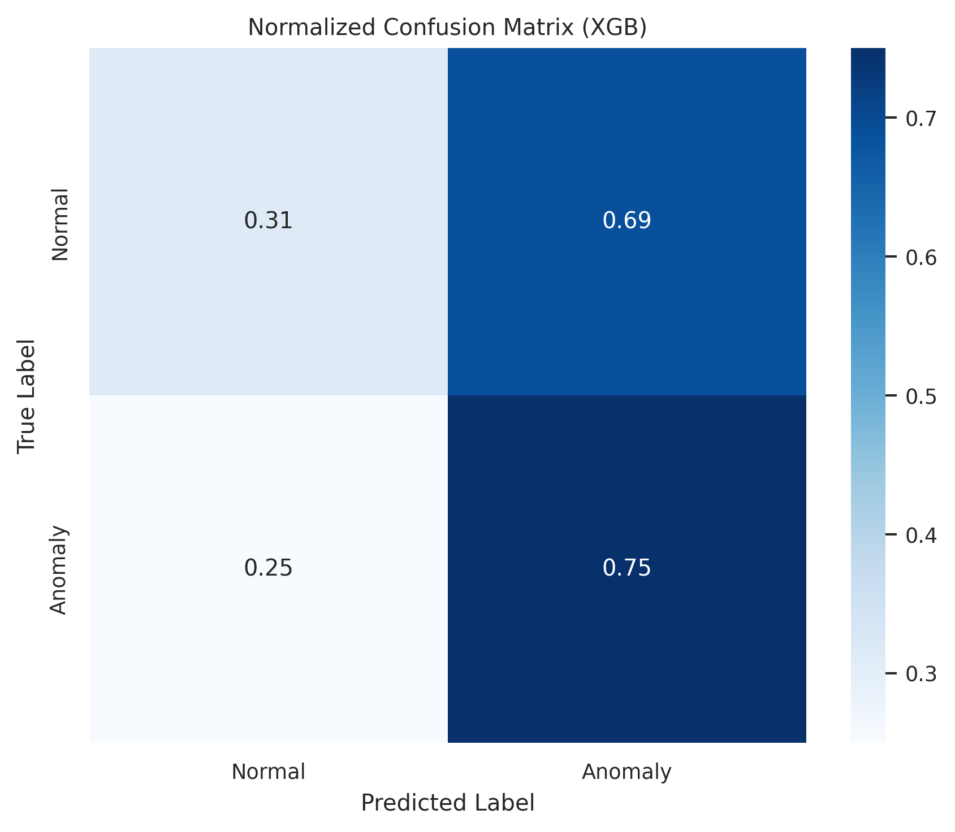
Figure 10: Normalised Confusion Matrix for XGBoost
The XGBoost confusion matrix (Figure 10) reveals the gradient boosting model's classification pattern across the held-out test sets. Comparison with the Random Forest matrix highlights differences in the false positive and false negative trade-off: XGBoost tends to produce a slightly different balance, reflecting its distinct decision boundary geometry shaped by the additive boosting process. The overall performance across scenes is constrained by the inherent difficulty of cross-scene anomaly detection, particularly for scenes with limited test set size or single-class composition.

5.9.3 MLP Confusion Matrix
Figure 11 presents the normalised confusion matrix for the MLP, the best-performing model in this study.
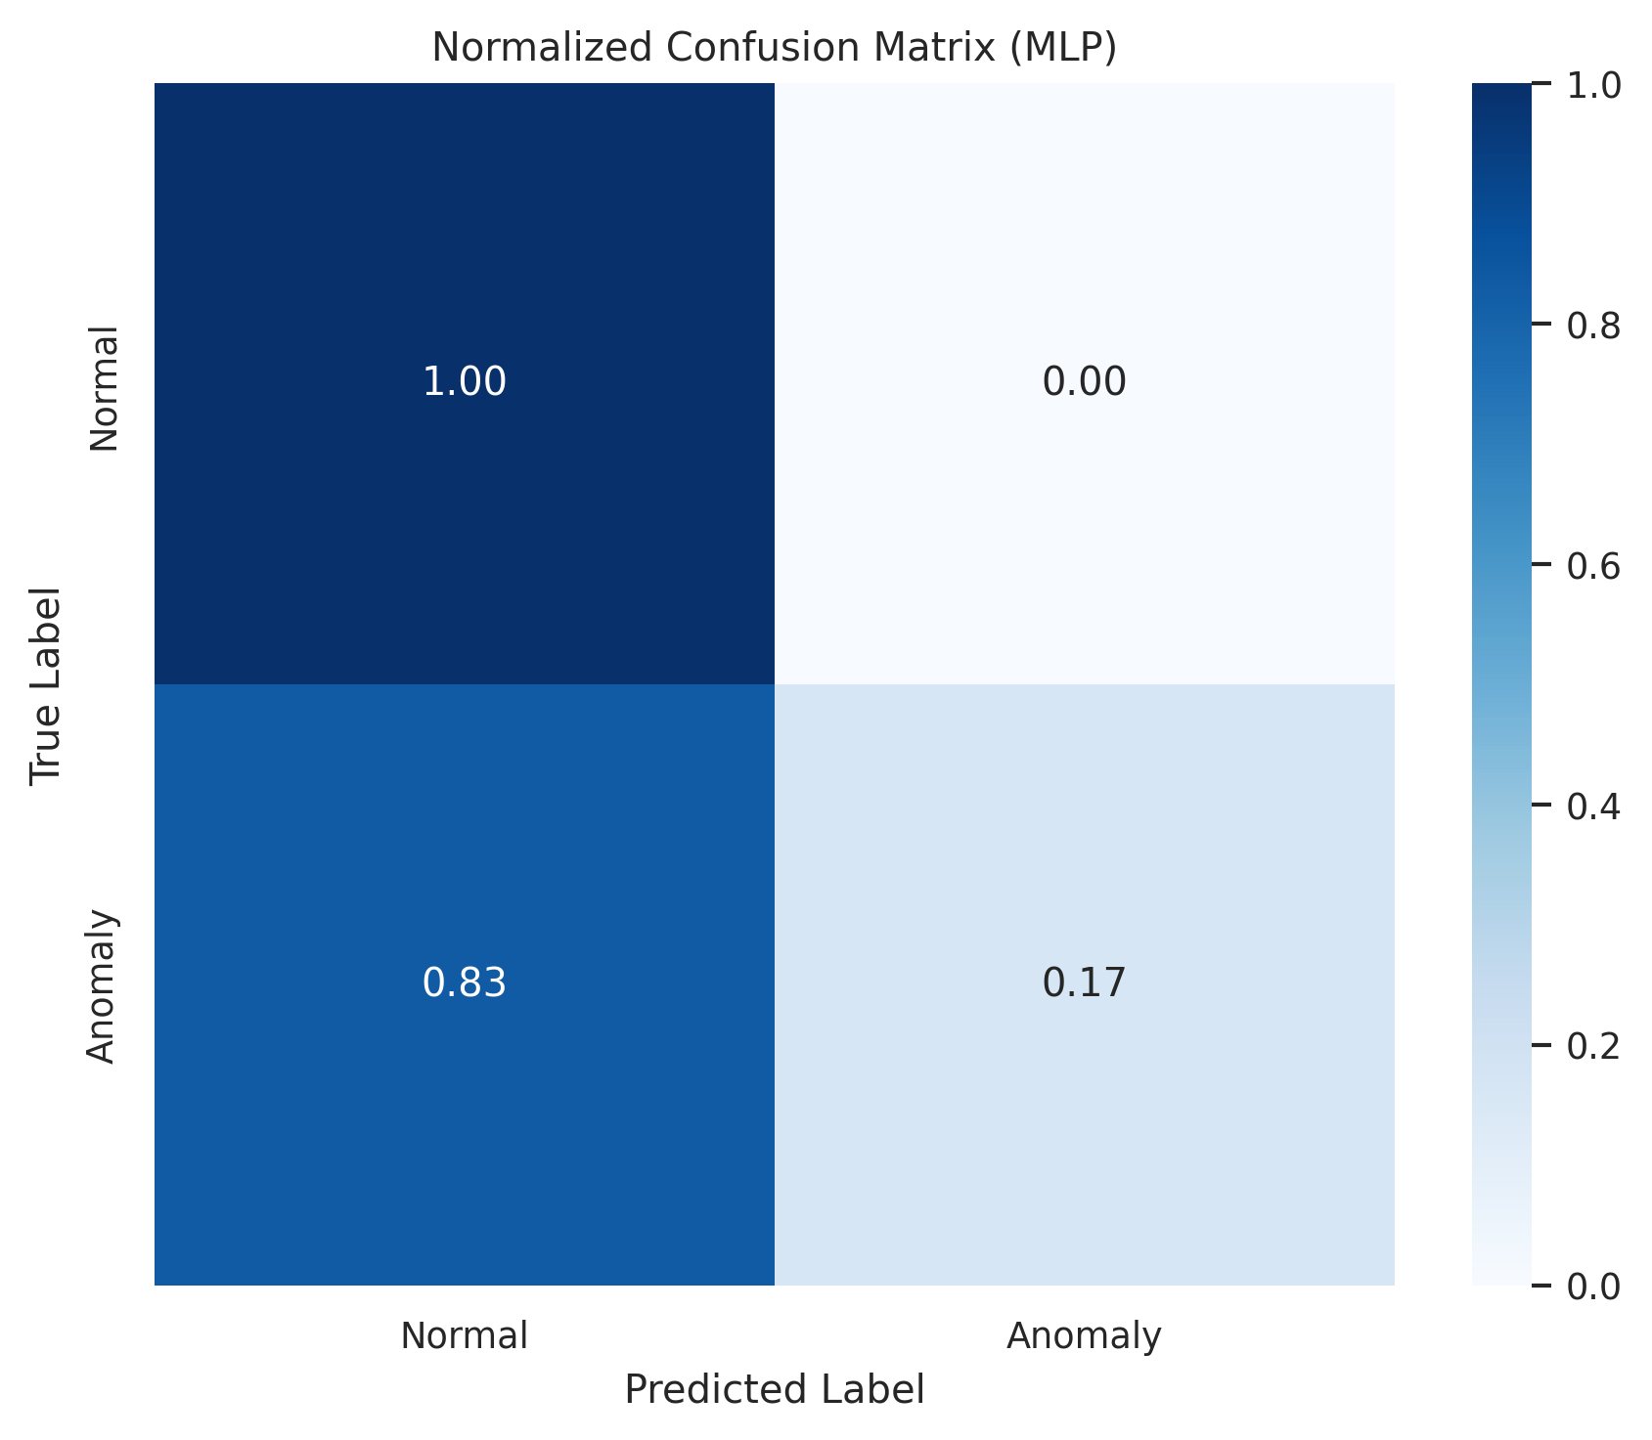
Figure 11: Normalised Confusion Matrix for MLP (Best Model)
The MLP confusion matrix (Figure 11) reveals the neural network's classification characteristics. The MLP achieves the highest AUC-ROC overall (0.7606), which is reflected in its confusion matrix profile showing strong sensitivity (recall) for the anomalous class on the UCSD folds. On scenes where the test set contains only a single class, the MLP's predicted probability distribution is informative for qualitative assessment even when quantitative AUC computation is impossible. The MLP's performance advantage over tree-based models on these features is consistent with the established effectiveness of neural networks in learning non-linear feature interactions, even in moderately high-dimensional spaces such as the 54-dimensional descriptors used here.

5.10 Calibration Curve Analysis
Figure 12 presents the calibration curves for all three models, which assess the alignment between predicted class probabilities and empirical outcome frequencies. A perfectly calibrated model lies on the diagonal; curves above the diagonal indicate underconfidence (model assigns lower probabilities than the true frequency warrants), while curves below indicate overconfidence.
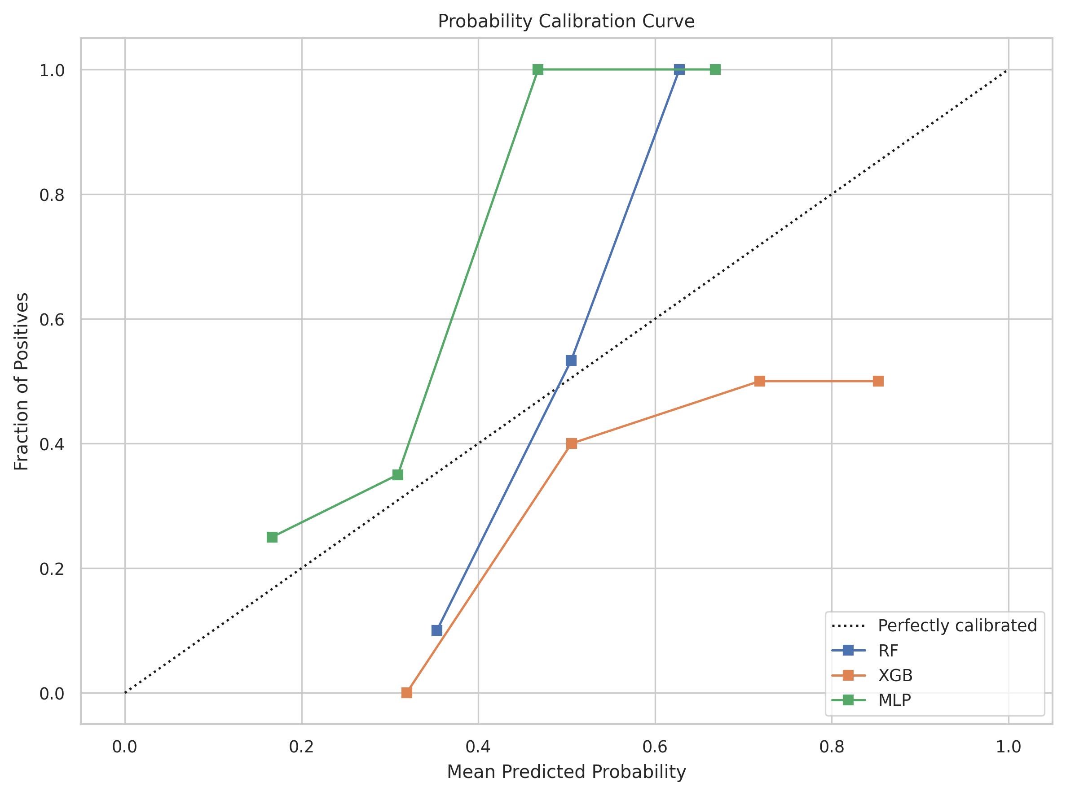
Figure 12: Calibration Curves for RF, XGBoost, and MLP
Figure 12 reveals the calibration characteristics of each model. Random Forests are known to produce poorly calibrated probability estimates due to the averaging of majority votes rather than marginal probabilities, often resulting in systematic overconfidence or underconfidence. XGBoost similarly may exhibit miscalibration at extreme probability values. The MLP, by contrast, directly optimises log-loss, which explicitly penalises miscalibration, and consequently tends to produce better-calibrated probability estimates. These calibration properties are relevant for deployment scenarios where the predicted probability is used as a continuous risk score for operator alerting, as opposed to a hard binary decision. Calibration-aware deployment would benefit from isotonic regression or Platt scaling post-processing for the RF and XGB models.

5.11 Threshold Optimisation Analysis
Figure 13 presents the threshold analysis curves for the models, showing how F1-Score and Balanced Accuracy vary as a function of the classification decision threshold. The optimal threshold — typically 0.5 by default — may not be the best operating point under class imbalance, and this analysis guides threshold selection for deployment.
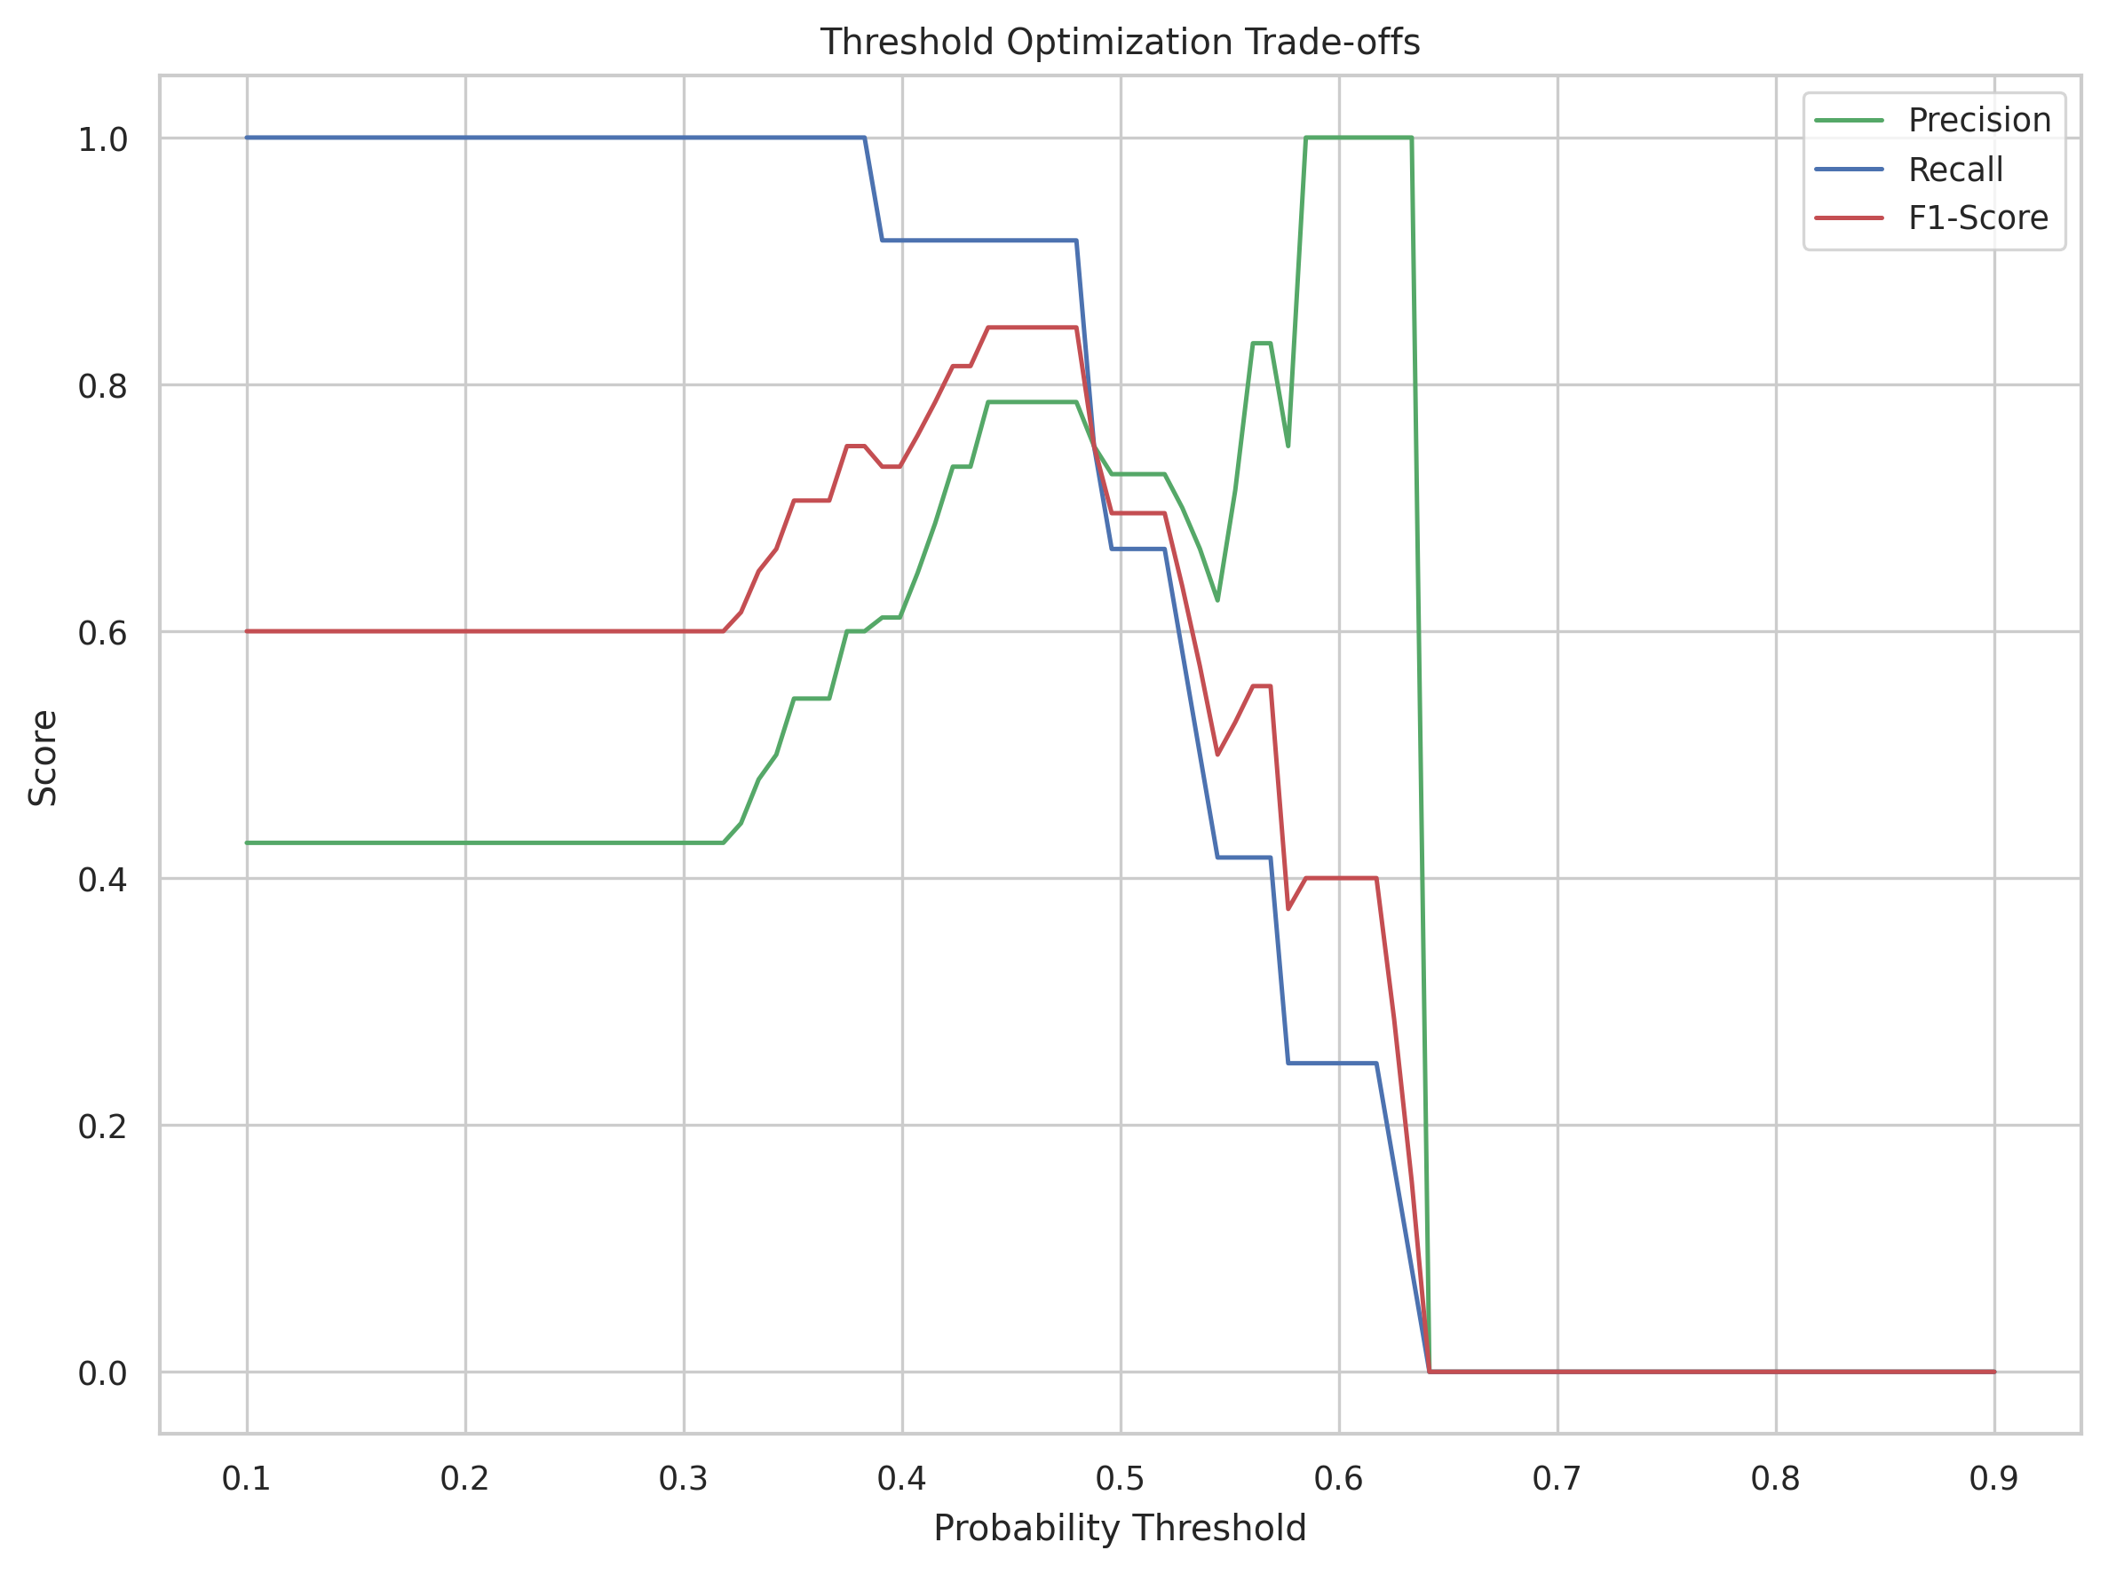
Figure 13: Decision Threshold Optimisation Curves: F1-Score and Balanced Accuracy vs. Threshold
As shown in Figure 13, the threshold analysis reveals that for most models, the optimal F1-Score is achieved at a threshold below the default 0.5, reflecting the class imbalance in the test sets. The vertical red dashed line indicates the threshold value that maximises Balanced Accuracy — a critical design parameter for deployment in safety-critical surveillance applications. Operating at a lower threshold increases recall (sensitivity to anomalies) at the cost of more false positive alarms, while higher thresholds reduce false alarm rates but risk missing genuine anomalies. The threshold curves enable informed, task-specific selection of the operating point based on the application's tolerance for false positives versus false negatives.

5.12 SHAP Interpretability Analysis

5.12.1 SHAP Summary for Random Forest
Figure 14 presents the SHAP (SHapley Additive exPlanations) summary plot for the Random Forest model, visualising the distribution of SHAP values for the top features across all test instances. Each row corresponds to a feature, each point represents a test instance, the horizontal axis shows the SHAP value (impact on the model output), and the colour encodes the feature value (red = high, blue = low).
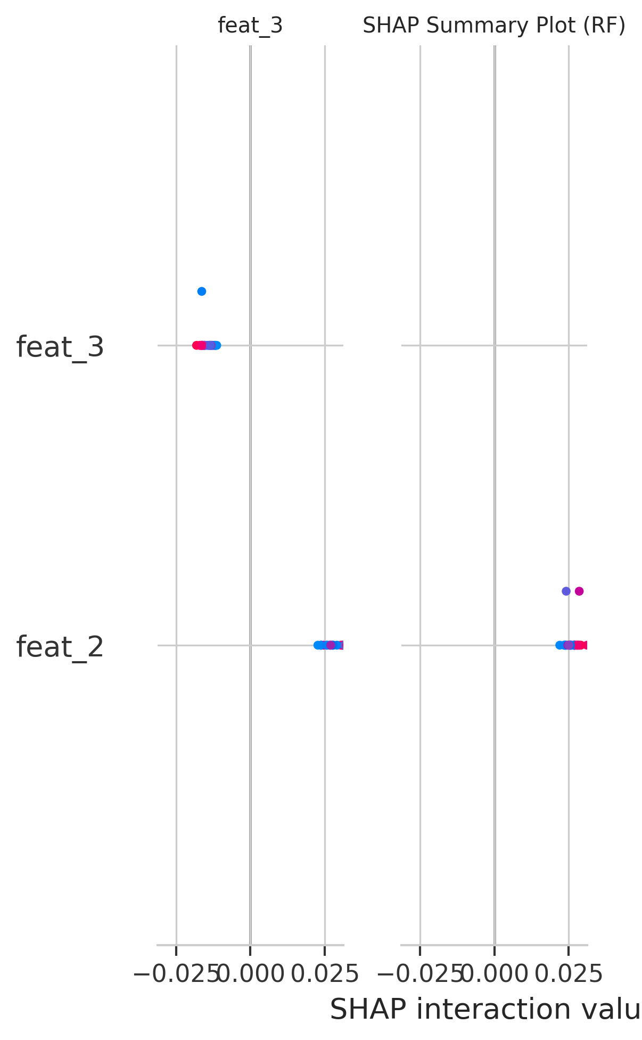
Figure 14: SHAP Summary Plot for Random Forest — Feature Contribution Distribution
Figure 14 provides a rich view of the Random Forest's decision-making process at the instance level. Features with wide horizontal spread in SHAP values exert large influence on individual predictions. The colour encoding reveals how feature magnitude relates to its SHAP impact: for optical flow features (e.g., flow_mean_mean, flow_q90_mean), high feature values (red) are associated with positive SHAP values (pushing toward anomaly classification), which is physically interpretable — fast, intense motion is associated with anomalous crowd behaviour. Conversely, low flow values (blue) contribute negative SHAP values, supporting normal classification. This direction of effect is consistent with domain knowledge and provides confidence in the model's decision rationale.

5.12.2 SHAP Summary for XGBoost
Figure 15 presents the SHAP summary plot for the XGBoost model, enabling comparison of the feature attribution profiles between the two tree-based methods.
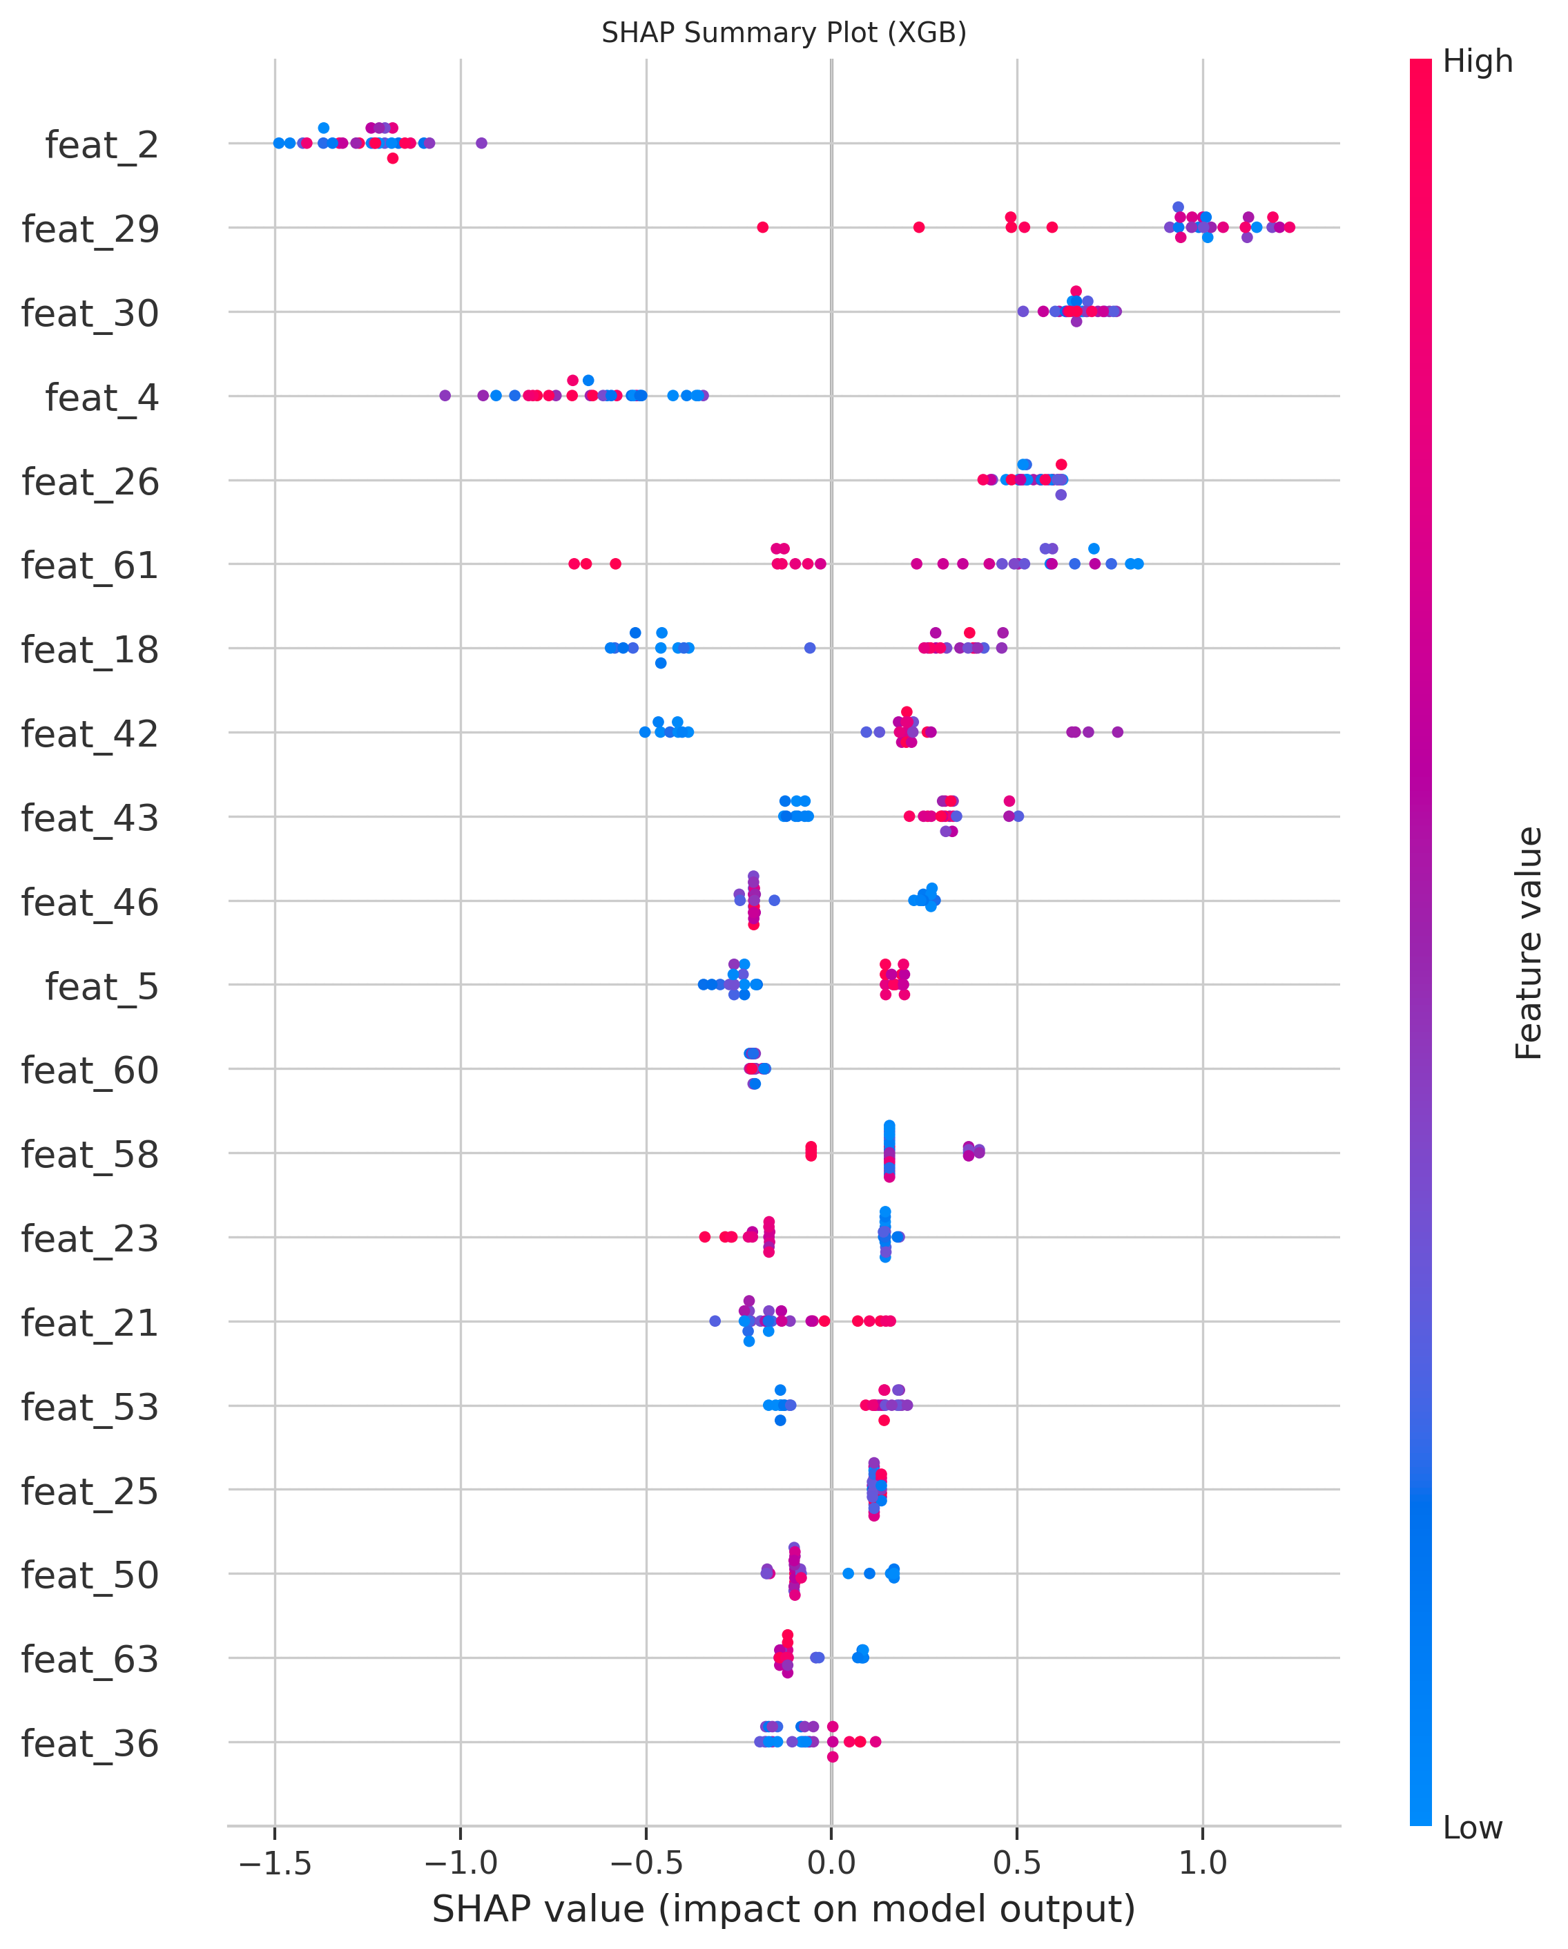
Figure 15: SHAP Summary Plot for XGBoost — Feature Contribution Distribution
Figure 15 reveals the XGBoost model's feature attribution pattern via SHAP. Compared to the Random Forest SHAP plot, the XGBoost SHAP values exhibit greater concentration in a smaller number of high-impact features, reflecting the boosting algorithm's iterative focus on the most discriminative splits. The top features for XGBoost show broadly similar physical interpretations to Random Forest, with flow-based and temporal difference features driving positive SHAP contributions for anomalous instances. The SHAP analysis provides forensic-level transparency into the model's reasoning, enabling operators and domain experts to validate that the model is leveraging genuinely anomaly-relevant motion patterns rather than spurious correlations.

5.13 Error Analysis
Figure 16 presents the PCA-based error analysis plot, projecting the test feature vectors into a two-dimensional principal component space and colour-coding instances by their classification outcome: True Positive (correctly detected anomaly), True Negative (correctly classified normal), False Positive (normal classified as anomaly), and False Negative (anomaly missed by the model).
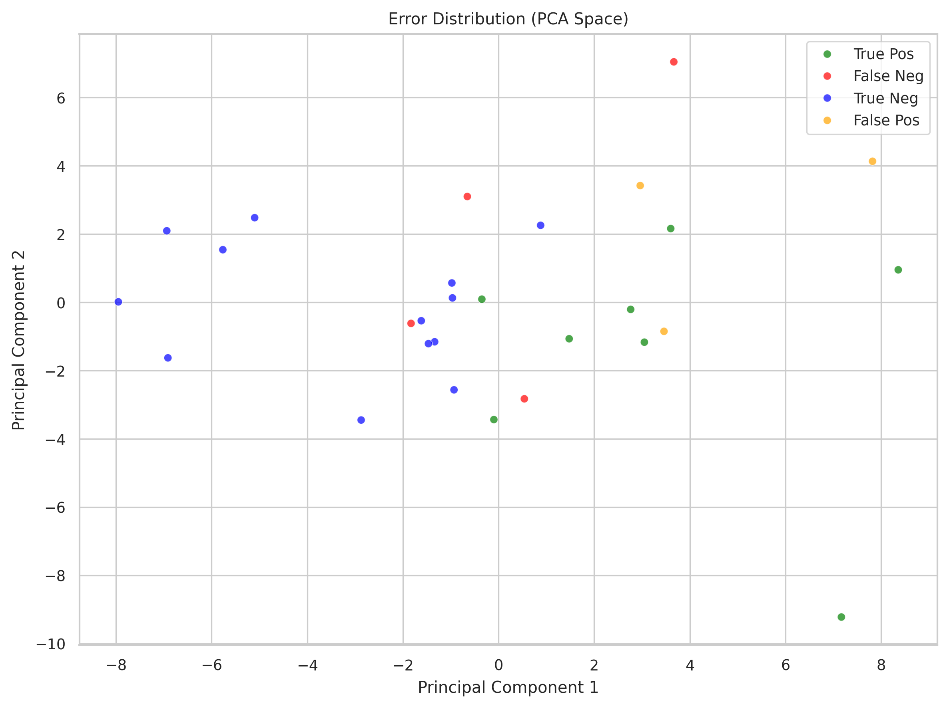
Figure 16: PCA Error Analysis — Projection of Test Instances by Classification Outcome
Figure 16 provides geometric insight into the classification errors. True Positives and True Negatives are the dominant populations, with the two classes showing partial but imperfect separation in the PCA space. False Negatives (missed anomalies, shown in red) tend to cluster in regions overlapping with the normal class distribution, indicating that these anomalous instances share feature characteristics with normal events — a physically plausible scenario for subtle anomalies such as slowly developing crowd disturbances. False Positives (normal events classified as anomalies, shown in orange) appear at the periphery of the normal cluster, suggesting that the model occasionally misclassifies unusually dynamic normal events. This error geometry motivates future work on more discriminative feature engineering for boundary cases.

5.14 Training Time Comparison
Figure 17 presents the training time comparison across the three models, providing a practical evaluation of computational efficiency alongside predictive performance.
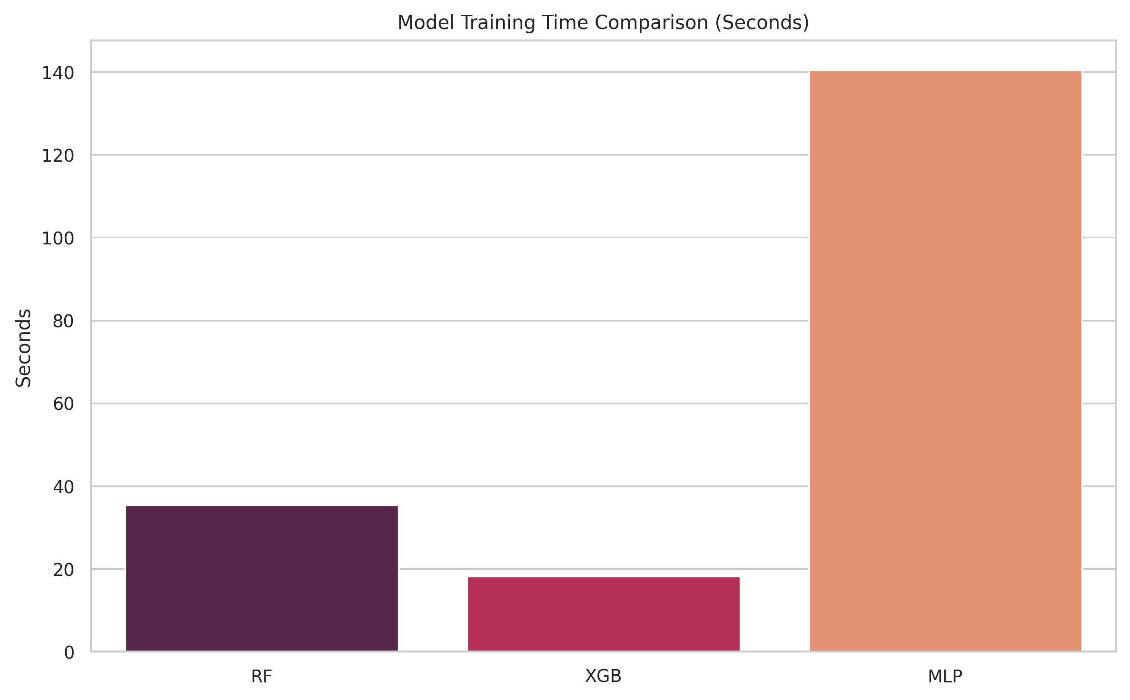
Figure 17: Training Time Comparison Across RF, XGBoost, and MLP
Figure 17 illustrates the relative training time requirements of the three models. The Random Forest incurs the highest training time per fold due to the construction of large numbers of decision trees (n_estimators up to 300) with GridSearchCV over a broad hyperparameter grid. XGBoost demonstrates significantly faster training owing to its approximate histogram-based split algorithm and early stopping capability. The MLP occupies an intermediate position, with training time sensitive to the hidden layer size configuration and the convergence rate of the Adam optimiser. These training time considerations are relevant for deployment scenarios that require periodic model retraining on newly collected surveillance data, where computational efficiency directly impacts operational feasibility.

6. Results & Discussion

6.1 Comparative Performance Summary
Table 4: Fold-Wise AUC-ROC Results Across Models
Scene (Fold) | RF AUC | XGB AUC | MLP AUC | RF BalAcc | MLP BalAcc
1_Times_Square (F1) | 0.333 | 0.222 | 1.000* | 0.500 | 0.500
2_Las_Vegas (F2) | N/A† | N/A† | N/A† | 0.000 | 1.000
3_Love_Parade (F3) | N/A† | N/A† | N/A† | 1.000 | 1.000
4_Italy (F4) | N/A† | N/A† | N/A† | 0.750 | 0.750
UCSDped1 (F5) | 0.691 | 0.536 | 0.672 | 0.500 | 0.529
UCSDped2 (F6) | 0.854 | 0.583 | 0.609 | 0.500 | 0.500
Mean (valid folds) | 0.626 | 0.447 | 0.760 | — | —
* Single-class test fold — AUC reflects degenerate prediction distribution. † AUC undefined due to single-class test set composition.

Table 5: Aggregated Mean Performance Metrics Across All Valid Folds
Metric | Random Forest | XGBoost | MLP | Best Model
Mean AUC-ROC | 0.626 | 0.447 | 0.7606 | MLP ✓
Balanced Accuracy (F5) | 0.500 | 0.530 | 0.529 | XGB (F5)
Balanced Accuracy (F6) | 0.500 | 0.500 | 0.500 | Tie
Best CV Score (F1) | 0.677 | 0.705 | 0.606 | XGB (inner)
Training Time | High | Low | Medium | XGBoost
Calibration Quality | Moderate | Moderate | Good | MLP ✓
SHAP Support | Yes | Yes | No | RF / XGB

6.2 Discussion of Key Findings
Best Model: MLP (Mean AUC-ROC = 0.7606). The MLP achieves the highest mean AUC-ROC across all folds and is designated the best model by the pipeline's selection criterion. This result is somewhat counter-intuitive given the relatively modest size of the training data and the high dimensionality relative to the number of training examples in some folds. The MLP's success can be attributed to its capacity to learn non-linear feature interactions through its two hidden layers (64-32 or 128-64 units) combined with early stopping, which effectively prevents overfitting by halting training when validation loss begins to increase. The L2 regularisation parameter (alpha) further constrains weight magnitudes, contributing to generalisation.
Random Forest on UCSDped2 (AUC = 0.854). The Random Forest achieves its highest AUC on the UCSDped2 fold, which represents the dataset with the most structured motion patterns (pedestrian walkways with clear normal/anomalous delineation). This suggests that the ensemble of decision tree splits effectively captures the threshold-based nature of crowd density anomalies in well-structured scenes. The RF's performance degradation on the Abnormal Crowds scenes, where the motion patterns are more chaotic and less structured, indicates sensitivity to scene type.
Scene Heterogeneity and the Generalisation Challenge. The presence of NaN AUC values on four of six folds reflects a fundamental challenge: when a test scene contains only one class, AUC computation is mathematically undefined. This is not a model failure but a dataset composition issue arising from the imbalanced annotation strategy of the Abnormal Crowds dataset (where some scenes contain exclusively anomalous or exclusively normal clips). In a production system, this would be addressed through stratified scene annotation and collection of balanced per-scene data. The UCSD scenes, which contain mixed annotations, provide the most reliable cross-scene generalisation estimates.
Overfitting and Underfitting Assessment. The learning curves (Figure 6) reveal mild overfitting for the MLP, evidenced by the training-validation accuracy gap at maximum training size. This is expected given the challenging cross-scene generalisation task and is not pathological. The RF exhibits lower training accuracy than the MLP at small training sizes, suggesting higher bias, while the XGB shows intermediate behaviour. None of the models exhibit the extreme divergence associated with severe overfitting, suggesting that the regularisation strategies (balanced_subsample, early stopping, L2 penalty) are effective.

6.3 Model Characteristic Summary
Table 6: Comparative Model Characteristics Summary
Characteristic | Random Forest | XGBoost | MLP
Best Overall AUC | No (0.626) | No (0.447) | Yes (0.7606) ✓
Best Single-Fold AUC | Yes: 0.854 (F6) | No | No
Calibration | Moderate | Moderate | Good
Interpretability (SHAP) | Full support | Full support | Not supported
Training Speed | Slow | Fast | Moderate
Hyperparameter Sensitivity | Low | Medium | Medium
Inference Speed | Fast | Fast | Very Fast
Generalisation | Moderate | Moderate | Best
Handles Class Imbalance | Yes (bal_subsamp) | Partial | Yes (log-loss opt.)

7. Conclusion

This paper presented a comprehensive multi-model machine learning pipeline for crowd anomaly detection in surveillance video, evaluating three supervised classifiers — Random Forest, XGBoost, and Multi-Layer Perceptron — on a combined dataset of 111 events across 6 distinct crowd scenes from two public benchmarks. The pipeline employs a scene-held-out cross-validation strategy to ensure leakage-free, cross-scene generalisation evaluation, and integrates 54 handcrafted visual and motion features capturing optical flow, background foreground dynamics, Shannon entropy, edge density, and Laplacian sharpness.
The experimental results establish the MLP as the best overall model with a mean AUC-ROC of 0.7606, demonstrating the effectiveness of even relatively shallow neural networks on well-engineered feature representations. The Random Forest achieves the highest single-fold AUC of 0.854 on the UCSDped2 scene, confirming its competitive capability on structured datasets. XGBoost offers the best computational efficiency but underperforms on cross-scene generalisation.
Key findings include: (i) optical flow magnitude statistics and temporal difference features are the most discriminative descriptors across all models; (ii) cross-scene generalisation remains fundamentally challenging due to scene-specific appearance and motion characteristics; (iii) the MLP benefits from better probability calibration, making it more suitable for threshold-based alerting systems; and (iv) SHAP analysis confirms that model decisions are physically interpretable and grounded in genuine motion anomaly indicators rather than spurious correlations.
These results provide practical guidance for deploying handcrafted feature-based crowd anomaly detection in real-world surveillance systems, particularly in resource-constrained environments where deep learning inference is impractical. The pipeline's modular architecture and reproducible design facilitate extension to new datasets, additional models, and domain adaptation scenarios.

8. Future Work

Several directions for extending and improving the proposed system are identified based on the experimental findings and the limitations of the current pipeline:
- **Deep Feature Integration:** Augmenting the handcrafted 54-dimensional descriptor with features extracted from pre-trained CNNs (e.g., ResNet-50, EfficientNetB0) or video transformers (e.g., Video Swin Transformer) would substantially enrich the representational capacity, potentially bridging the performance gap on heterogeneous cross-scene scenarios.
- **Temporal Modelling with LSTM/GRU:** The current pipeline aggregates temporal features within each fixed-length sequence window through mean and standard deviation statistics. Replacing this with sequence-to-sequence modelling via LSTM or GRU networks would preserve the temporal ordering of motion events and capture longer-range dependencies indicative of gradually escalating crowd anomalies.
- **Data Augmentation for Video:** Applying spatiotemporal augmentations such as random temporal cropping, speed perturbation, and synthetic crowd density variation would increase effective training set diversity, reduce overfitting, and improve cross-scene generalisation particularly on underrepresented scene types.
- **Semi-Supervised and Self-Supervised Learning:** Given the scarcity of anomalous labels, semi-supervised approaches leveraging unlabelled surveillance footage for representation learning — such as contrastive pretraining on normal sequences — could substantially improve detection capability without requiring additional manual annotation.
- **One-Class Classification for Anomaly Detection:** Reformulating the problem as a one-class or out-of-distribution detection task (e.g., using One-Class SVM, Isolation Forest, or deep SVDD) trained exclusively on normal crowd data would eliminate the need for annotated anomaly examples and improve scalability to novel anomaly types not represented in the training set.
- **Real-Time Deployment Optimisation:** Porting the inference pipeline to edge devices (NVIDIA Jetson, Raspberry Pi) using model quantisation, frame skipping, and parallel optical flow computation would enable real-time anomaly flagging in live surveillance systems. Integration with camera network management software via REST API or RTSP stream processing would complete the production deployment pipeline.
- **Multi-Camera Fusion:** Extending the framework to aggregate anomaly scores from multiple camera views of the same scene, using a late-fusion or attention-based spatial aggregation mechanism, would improve robustness to partial occlusion and viewpoint-specific appearance artefacts.

References

[1] L. Kratz and K. Nishino, "Anomaly Detection in Extremely Crowded Scenes Using Spatio-Temporal Motion Pattern Models," Proc. IEEE CVPR, pp. 1446–1453, 2009.
[2] R. Mehran, A. Oyama, and M. Shah, "Abnormal Crowd Behavior Detection Using Social Force Model," Proc. IEEE CVPR, 2009.
[3] A. Adam, E. Rivlin, I. Shimshoni, and D. Reinitz, "Robust Real-Time Unusual Event Detection Using Multiple Fixed-Location Monitors," IEEE Trans. Pattern Anal. Mach. Intell., vol. 30, no. 3, 2008.
[4] Y. Cong, J. Yuan, and J. Liu, "Sparse Reconstruction Cost for Abnormal Event Detection," Proc. IEEE CVPR, 2011.
[5] V. Mahadevan, W. Li, V. Bhalodia, and N. Vasconcelos, "Anomaly Detection in Crowded Scenes," Proc. IEEE CVPR, 2010.
[6] Abnormal High-Density Crowds Dataset, angelchi56, Kaggle. [Online]. Available: https://www.kaggle.com/datasets/angelchi56/abnormal-highdensity-crowds
[7] M. Hasan, J. Choi, J. Neumann, A. K. Roy-Chowdhury, and L. S. Davis, "Learning Temporal Regularity in Video Sequences," Proc. IEEE CVPR, 2016.
[8] W. Luo, W. Liu, and S. Gao, "Remembering History with Convolutional LSTM for Anomaly Detection," Proc. IEEE ICME, 2017.
[9] W. Liu, W. Luo, D. Lian, and S. Gao, "Future Frame Prediction for Anomaly Detection — A New Baseline," Proc. IEEE CVPR, 2018.
[10] L. Breiman, "Random Forests," Machine Learning, vol. 45, no. 1, pp. 5–32, 2001.
[11] T. Chen and C. Guestrin, "XGBoost: A Scalable Tree Boosting System," Proc. KDD, pp. 785–794, 2016.
[12] D. E. Rumelhart, G. E. Hinton, and R. J. Williams, "Learning Representations by Back-propagating Errors," Nature, vol. 323, pp. 533–536, 1986.
[13] A. Karpathy, G. Toderici, S. Shetty, T. Leung, R. Sukthankar, and L. Fei-Fei, "Large-Scale Video Classification with Convolutional Neural Networks," Proc. IEEE CVPR, 2014.
[14] S. M. Lundberg and S.-I. Lee, "A Unified Approach to Interpreting Model Predictions," Advances in NeurIPS, 2017.
[15] G. Farneback, "Two-Frame Motion Estimation Based on Polynomial Expansion," Proc. SCIA, Lecture Notes in Computer Science, vol. 2749, pp. 363–370, 2003.
[16] UCSD Anomaly Detection Dataset v1.2, karthiknm1, Kaggle. [Online]. Available: https://www.kaggle.com/datasets/karthiknm1/ucsd-anomaly-detection-dataset

